The Open-air Solar Power Laboratories of the Finnish Meteorological Institute 2
Abstract 2
Keywords 3
Dataset details 3
1. Introduction 3
2. Data Description 4
2.1. Characteristics of FMI’s open-air solar power laboratories 4
2.1.1 Helsinki and Kuopio Open-air PV Labs 4
2.1.1 Sodankylä Open-air PV Lab 5
2.1.2 Ancillary data (Anders) 5
2.2 Snow status classification and QC methods 6
2.2.1 Visual QC inspection with snow status classification 6
2.2.2 Application of the Visser PVQC 6
2.3 PV data quality 7
2.3.1 Snow status of the modules: classification results and validation 7
2.3.2 Visser PVQC filtering: results and evaluation 8
2.3.3 Shading 10
2.3.4 QC synthesis of the PV data from the FMI Open-air Solar Power Laboratories 12
2.4 General characteristics of the PV production 12
3. Dataset Access 13
4. Dataset use and potential reuse 13
5. Conclusions 14
Acknowledgements 14
Conflicts of Interest 14
List of supporting information 15
References 15
Figures and tables 18
Table 1 Specifications of the PV systems of the FMI’s open-air solar power laboratories 19
Figure 1. Locations of the open-air solar power laboratories of FMI and typical ending date of permanent snow cover (1991-2020 normal period) in Finland. 20
Figure 2. Helsinki PV system. 21
Figure 3. Kuopio PV system. 23
Figure 4. Sodankylä PV modules. 24
Figure 5: Quality control and snow status classification graph. 25
Table 2. Annual number of days of PV systems in each snow status category 27
Figure 6. Daily snow status of the PV systems. 29
Table 3: Snow status validation statistics of the Sodankylä modules between 27 Feb 2018 and 31 Dec 2021. 30
Table 4. Incidences of complete and swift clearances of snow. 31
Table 5. Results of Visser PVQC filtering. 32
Figure 7. Distribution of Visser PVQC upper limit filter triggerings 33
Table 6. Annual output of the PV systems 34
Figure 8. Nominal power output of the FMI PV systems 38
Figure 9. Average P^{meas} as a function of sun position 39
Figure 10. Daily averages of PV production by month 41
Supporting information 42
S1: Nomenclature 43
S2: The Visser PVQC filter equations 45
S3: Visser PVQC filtering: results and evaluation in detail 48
S4: Description of shade casting obstacles in the PV sites 60
S5: Snow clearance incidences of the Sodankylä 20° module 65

The Open-air Solar Power Laboratories of the Finnish Meteorological Institute
Karhu J.A., Lindfors A.V., Wandji Nyamsi W., Poikonen A., Mielonen T., Pitkänen M., and Salola T.
Finnish Meteorological Institute

Abstract
High-quality, long-term time series of photovoltaic (PV) output measurement data at high latitudes are very scarce, limiting both academic research and commercial applications in this area. In this paper, we present and publish high-resolution (1 min) PV output data, along with ancillary measurements, from three high-latitude sites in Finland, collected between 26 August 2015 and 31 December 2021. The PV data, consisting of averaged power readings, were retrieved from inverter registries. Ancillary data from the PV field, including plane-of-array irradiance, air temperature, module temperature, and camera images of the modules, were collected using separate measurement systems. Additionally, meteorological variables, such as radiation components and snow depth, were obtained from nearby weather stations maintained by the Finnish Meteorological Institute. We performed daily snow cover classification on the modules based on numerical data, partially validated by camera images. In addition to visual inspection, the PV data underwent a quality control routine as described by Visser et al. (2020), though we found it not fully effective for our purposes. Snow cover was found to vary significantly based on site location and PV system design. Subsets of this dataset have previously been used for PV output model validation, and the complete dataset holds potential for further applications, including PV model development, performance metric enhancement for high-latitude installations, and studies on snow-related losses and gains. The data is freely available at the Finnish Meteorological Institute's METIS data repository.

Keywords
photocoltaics, PV output, ancillary data, snow, quality control

Dataset details
Identifier: 10.57707/fmi-b2share.d7407bbaca2145afa109d757b00cf086
Creators: Juha A. Karhu and Anders Lindfors
Dataset correspondence: JuhaA.Karhu@fmi.fi
Title: PV production data with ancillary PV and meteorological data including solar radiation measurements from FMI's open-air solar laboratories in Helsinki, Kuopio and Sodankylä (Finland) starting from August 2015 and ending Dec 2021
Data centre: METIS - FMI’s Research Data repository
Publisher: Finnish Meteorological Institute
Publication year: 2024
Resource type: Dataset with photographs
Version: 1.0

1. Introduction
Installed solar photovoltaic (PV) capacity is growing quickly, both worldwide (International Energy Authority, 2023) and in Finland. At present, the majority of installed capacity in Finland consists of either small domestic or small commercial systems under 1 MWp. Industrial scale PV installations have started to emerge recently, and they are expected to be relevant in Finland in the future. (Energy Authority, 2023)
Understanding the relationship between prevailing meteorological conditions and solar PV output is important for several applications related to PV system performance such as understanding the lifetime expected electricity output of a PV system, monitoring PV system health and forecasting the PV output (e.g., Huld et al., 2010; Böök and Lindfors., 2020; Alcañiz et al., 2022). In particular, in the Nordic climate, seasonal snow cover is an especially important aspect to consider, as snow conditions may significantly alter the solar PV production (e.g., Böök et al., 2020; Øgaard et al., 2021; van Noord et al., 2021). Also, low sun conditions prevalent in the Nordics complicate quality control and performance evaluation (Karttunen et al. 2023). There are open PV output datasets available for research community such as Yao et al. (2021), Silwal et al. (2021), Vink, Ankyu and Koyama (2019), Visser et al. (2022), but we are not aware of any such datasets from high latitudes (> 60°) with snowy climate and large share of low sun conditions.
In order to systematically collect measurement-based information on meteorological conditions and analyze how they influence the solar PV output in the Nordic conditions, the Finnish Meteorological Institute (FMI) has deployed solar PV power plants with supporting meteorological and ancillary measurements. There are currently three solar PV sites operated by FMI: Helsinki, established in 2015; Kuopio (2016) (operated jointly with University Properties of Finland Ltd) and Sodankylä (2017) (Figure 1). The aim of this paper is to describe the deployed measurement and data logging systems, perform initial quality control of the data together with snow status categorization, test the PV quality control (QC) routine of Visser et al. (2022), hereafter referred to as Visser PVQC and, finally, document and share the available data with the scientific community.

2. Data Description

2.1. Characteristics of FMI’s open-air solar power laboratories
In this section we describe the characteristics of the surroundings, platforms and equipment of the PV and meteorological measurements of the three open-air solar power laboratories of FMI. The laboratories are located in distinctly different geographic locations in southern, central and northern Finland. Consequently, the snow climates (Figure 1) and the ranges of solar zenith angles are also different at the three sites. Specifications of the module installations of all three laboratories are summarized in Table 1. A detailed description of nearby obstacles casting shades on the modules is given in Supporting information S4 and discussed in the light of PV data in Chapter 2.3.3. The PV systems have been maintained with minimum interference. Thus, there has been no cleaning or snow removal performed on the modules. Only technical faults, such as replacing defective components, have been resolved.

2.1.1 Helsinki and Kuopio Open-air PV Labs
The PV systems of Helsinki and Kuopio were designed to represent a typical, commercial, floating flat roof installation in Finland at the time. In both cases, the the roofs are covered with black bitumen felt. The module orientation follows those of the roofs’ edge: southeast (135°) in Helsinki and southwest (217°) in Kuopio. Noteworthy are the low module inclination angle (15°) compared to the latitudinal optimum (ca. 40°), and tight placement of the module rows, resulting in self-shading below ca. SZA 70° and high masking.
The PV modules of the FMI’s Helsinki solar power laboratory are installed on the roof of the FMI’s main office building in Kumpula, a mixed-use suburb of Helsinki (Figure 2). There are eighty-four solar modules in a landscape arrangement, in six equal size rows (14 modules in each row), and in two equal size strings (42 modules in both strings) connected to a string inverter.
The PV modules of the FMI’s Kuopio solar power laboratory are installed on the roof of the Melania building of the University of Eastern Finland in Savilahti, a science, education and administration district of Kuopio (Figure 2b). There are seventy-eight solar modules in a landscape arrangement in two uneven strings. The northern string 1 has 38 modules in two equal rows. The southern string 2 has 40 modules in four even rows.
Data from the inverters in Helsinki and Kuopio was collected with a Linux computer using a python script and Modbus protocol. In the beginning (from 28 August 2015 in Helsinki and 19 August 2016 in Kuopio) the inverter was sampled for PV power once per minute and the instant values were recorded. The sampling protocol changed on 21 June 2017 and 9 Aug 2017 in Helsinki and 18 September 2017 in Kuopio after which 60 samples per minute were collected, averaged to and recorded with 1 min t (time) and 0.1 W P (power) resolution. Between 21 June 2017 and 9 Aug 2017 in Helsinki the sampling rate was 12 times per minute as reported by Böök et al. (2020).

2.1.1 Sodankylä Open-air PV Lab
The Sodankylä PV system is much smaller than those at Kuopio and Sodankylä, as it consists of two independent one module systems with microinverters. The modules with 90° and 20° are installed in a portrait arrangement on top of each other on an open rack on the south-west corner of a 4 m high platform at a measurement field at Halssiaapa bog (Figure 2c). The platform is situated c. 900 m west of the Sodankylä weather station in the the FMI’s Arctic Space Centre. During the year 2017 the data was collected in batches from the inverter via manufacturer’s software and the resolution of P values was 12 W and t values 5 min. With the change of the inverters 26 February 2018, the sampling was changed similar to Helsinki and Kuopio.
The orientation of the modules is east-southeast (115°) towards an open bog with a fence at 86 m distance, the first sparse shrubbery at ca. 200 m and an edge of a proper forest at ca. 900 m from the PV systems. Except for east-southeast and southeast (ca. 140°), where the first higher vegetation is ca. 700 m and proper forest ca. 1.8 km away, sparse shrubbery encircles the measurement platform from most other sides at a few meters distance while distances to proper forest edge vary. To north-northeast (ca. 25°) and south-southwest (ca. 205°), i.e. perpendicular to the module orientation, the distance to proper forest edge is ca. 600 m and ca. 300 m, respectively.

2.1.2 Ancillary data (Anders)
- platforms
- Table of instruments and parameters
- quality control
In the beginning the module temperature measurements were by mistake subjected to FMI’s air temperature quality control routine. Due to the routine, the module temperature measurements prior to year 2019 suffer from artificial capping to 50°C.
OBS! Should we mention here the effect of wind direction on module temperature measurement differences?
Missing data (for filling up gaps of missing weather station data, we provide localized time series from ERA5 reanalysis):
Helsinki
Kuopio
Sodankylä,
- Occasionally differing features in radiation measurements in Tähtelä vs. Halssiaapa, eg. 17.11.2018, 7.6.2021 (probably cloud effects)
- calibration cycles

2.2 Snow status classification and QC methods
QC of the PV data was performed in two stages: i) visual inspection with snow status classification and ii) application of Visser PVQC. We chose Visser PVQC for the QC method as it was the most recent and the authors have made the python code publicly available at https://doi.org/10.5281/zenodo.6906504o, so that testing and evaluating the routine is possible.

2.2.1 Visual QC inspection with snow status classification
The PV data along with meteorological data from the sites were plotted on a daily basis (Figure 3). All the plots were visually inspected and noteworthy aspects were written down as remarks to the particular day. If there were substantial amount of missing PV data or the PV values did not seem to correspond to the expected values when assessed along with the meteorological parameters, especially irradiance data and snow depth, the day in question was flagged either as suspicious or, alternatively, some amount of snow on the modules was assumed. Especially in the melting season, module temperature measurements were used as an indicator for snow on the modules: when the module temperature did not rise above zero when the air temperature did, snow was assumed on the module. The differences in module teperature was used as an indication of possibly differential snow cover of the strings. The inferred amount of snow was classified to five categories: “no snow on the modules”, “unclear”, “probably at least partially covered with snow”, “probably extensively covered with snow”, and ”probably totally covered with snow”. No corrections were made to the data. The snow status classification for Sodankylä modules was validated with camera images similar to Figure 2c taken hourly between 27 February 2018 and 31 December 2021.

2.2.2 Application of the Visser PVQC
In the Visser PVQC, there are 8 distinct filters applied in 9 consecutive steps. Each of the filters can be distinguished as either an instant filter applied at a given instant $t$ of the day expressed in min, that modifies the value of $P$ at that given instant noted $P\left(t\right)$ or a day filter applied over a given day, that removes an entire day from the data set if the day does not obey the filter criteria. We applied the Visser PVQC to FMI’s PV data in the most straightforward and unaltered way that was possible. The main conceptual difference was that instead of creating a filtered version of the data, we only flagged it with the filter number in question. Also, in contrast to Visser et al. (2022), we applied the day filters in a parallel fashion instead of sequentially. This means that in our methodology, a particular day may be flagged with more than one day filter. We apply the instant filters sequentially as on one hand, they differ from each other so, that multiple filtering could not happen and on the other hand, their formulation is such that sequential application is required.
We found some errors in the formulation of the equations and the code by Visser et al. (2022) and have informed the authors about the them (L. Visser, personal communication, February 2, 2024). We present the equations in their correct formulation in Supporting information S2.

2.3 PV data quality
In northern climates the light attenuation by snow on modules can be mistaken with PV data quality problems. Therefore, we first present the instances when snow on modules seems to be the cause of less than optimum PV production. We consider the data of those instances as good quality if no additional evidence merits other conclusion. Secondly, we present the filtering results of the Visser PVQC and evaluate them based on the visual inspection of the daily plots and additional knowledge that we have on the performance of the systems. Thirdly, we discuss the shading issues of each PV system. Lastly, as a synthesis of snow status classification, Visser PVQC and visual inspection combined with shading analysis, we present our best estimate of the PV data quality features of the four systems at the three sites during 2015-2021.

2.3.1 Snow status of the modules: classification results and validation
We estimate that in Helsinki, there were snow on the modules on average during 61 days (17%), and in Kuopio during 148 days (41%) annually (Table 2 and Figure 4 top left and top right). The share includes classes “probably at least partly covered”, “probably extensively covered” and “probably totally covered with snow”. These figures are conservative estimates and represent the lower limit of our classification uncertainty. With including the “unclear” class to the share we would get the upper limit of the uncertainty, 76 days (21%) in Helsinki and 176 days (48%) in Kuopio.
In Sodankylä, camera images of the modules are available starting on 27 February 2018, which enabled validation of the inferred snow cover. The validation results are shown in Table 2, in more detail in Table 3 and in the bottom row of Figure 4. For 20° module there were false negative errors (classification to “no snow” -class when correct classification would have been some category of snow on the modules) on average 2.1% and false positive errors 3.7% of the days for months when snow was present. For 90° module the average false positive error rate was substantially larger, 22.3%, while no false negative errors were detected. The default, a priori assumption, that it would be almost impossible for snow to stick on the vertical module, turned out to be wrong. The biggest errors occured during the coldest and darkest months (Nov – Feb) when there was very little irradiation available and thus it was very difficult to infer the snow status. This means also, that in spite of large errors in snow classification, the absolute error in estimated annual power production would be negligible. The small average classification error of the 20° module, gives confidence in the snow status classification of the Helsinki and Kuopio modules with roughly similar module inclination.
Based on validated classification results of the Sodankylä systems there were snow on the 20° module on average during 144 days (40%) and on the 90° module during 59 days (16%) annually.
There are some interesting aspects in the snow status statistics of the different sites. In Kuopio the modules were covered by snow substantially more often than in Helsinki, which is in line with the facts that the PV systems are similar, but the climate is much snowier in Kuopio than in Helsinki. Nevertheless, there is no such big increase in snow cover when moving from Kuopio to Sodankylä even though the climate is even snowier in Sodankylä than in Kuopio. For the 90° module this is easily explained by the fact that it is much harder for the snow to be stuck on the module in the first-place due to verticality. The 20° module on the other hand does not differ substantially with its inclination from the Kuopio modules. One probable explanation to the discrepancy is the fact that, unlike in Helsinki and Kuopio, in Sodankylä the modules are installed in such a way that snow clearance by sliding can occur as there is enough free space below the leading edge (big clearance height) of each module row.
There were 90 snow clearance incidences identified on the Sodankylä 20° module from the camera images. These incidences and short descriptions of them are listed in Supporting information S5. Inspection of the images suggests that at least four processes are involved in the snow clearance: sliding, melting, sublimation and wind blowing the snow away from the module.

For the Sodankylä 20° module, several complete and fast clearances, apparently by sliding, of a substantial layer of snow were identified from the data and verified from the camera images (Table 4). All these incidences occurred when ambient air temperature rose a few tenths of a degree above zero. In Sodankylä the sliding snow has room to slide and fall completely off from the module. In Helsinki and Kuopio, where similar sliding events were not found, the front edges of the modules are close to the roof and complete sliding off of a substantial layer of snow is impossible. The possibility for sliding seems to have a big effect on the overall snow cover of the modules.

2.3.2 Visser PVQC filtering: results and evaluation
The filtering results of the Visser PVCQ are presented in Table 5. Here we give a summary the results and reflect them to findings in visual inspection. A detailed treatment of the results and findings are in Supporting information S3.
The Visser PVQC routine is designed to monitor and validate the performance of PV systems, identifying incorrect and missing PV data. However, while it successfully detects several issues, it also has limitations, including the erroneous filtering of what appears to be valid data. For example, in Kuopio, the routine identified some, but not all, of the data issues during periods when the PV system exhibited a "wake-up" problem each spring from 2017 to 2021, suggesting that the system failed to function optimally after winter.
Another critical aspect of the Visser PVQC routine is its performance during snow cover and heavy overcast conditions combined with high SZA. Here, the availability, linear and persistence filters often incorrectly filters out data, misinterpreting low irradiance and snow-covered modules as system faults. This results in the exclusion of data that might otherwise be considered normal under the Nordic conditions, thus reducing the reliability and availabilty of the data used for model validation and other analyses.
The upper limit filter is triggered in all four PV systems. The amount and distribution of upper limit filter triggerings probably have been affected somewhat due to inverter clippings. The smallest share of triggered minutes for all module conditions is found in Kuopio (0.25%) and the greatest share in Sodankylä 90° module (2.81%). Nevertheless, we did not find any credible case of actual system performance fault as a cause for filtering. In all studied cases, the G_{POA} showed similar features (spikes) as P^{meas}. Instead, we suspect that the upper limit filter is triggered mainly due to larger than allowed cloud enhancement (CE) and, for the Sodankylä 90° module especially, snow reflection. The distribution of the triggered cases shows major distortion towards high SZA, when the modules are facing away from the Sun (early morning for Kuopio or late evening for Helsinki and Sodankylä 20° module) (Figure 5a) and summer (Figure 5b) in all the sites except for the Sodankylä 90° module for which the peak number of cases are found during lower SZA (around noon) and spring. Therefore, we conclude that the Visser PVQC upper limit filter is too strict, and FMI’s real data (P^{meas}) is reasonable even with stronger CE than 1.4. Stronger CE is typical when sun is low and cloud fraction > 4/8 (Piedehierro et al. 2017, Gueymar 2014, Pecenak et al. 2016). Although not proved, it seems very plausible based on FMI’s data that inclined planes have stronger CE compared to CE in horizontal irradiance, and this is seen in particular for cases when the inclined plane is facing away from the sun (or at least not towards the sun). Therefore, an improvement of Visser's algorithm will require to include an CE depending on SZA/AOI for low Sun along with an algorithm that takes the reflection from snow into account better than the current clear-sky model. The amount and distribution of upper limit filter triggerings probably have been affected somewhat due to inverter clippings.
Inverter capping (clipping) happens when inverter capacity limits the output of the PV system. module (module) degradation happens over time and can attenuate inverter capping (Good and Johnson, 2016). The capping incidences and module degradation are not erroneous readings, but expected performance of the PV system that need to be taken in to account when analysing or using the data for scientific purposes, for example. Although, there is no filter in the Visser PVQC that specifically targets these phenomena, the linear filter does detect most of the severe capping incidences of Sodankylä 90° module during spring 2017. The capping incidences of Helsinki and Kuopio systems prevalent during the first years of operation (Fig. 9a and 9b) are undetected by the Visser PVQC. The inverter capping and module degradation are not analysed quantitatively in this study.
There is some spikiness, especially downward, unrelated to radiation variations in the FMI PV-data especially before the sampling method change in Helsinki and Kuopio in 2017. In Sodankylä spikiness increased after the microinverter changes in 2018 due to increase in the time and power resolutions of the data. In Sodankylä, there is only one module in each PV-system whereas in Helsinki and Kuopio tens of modules in the systems tend to smooth out spikiness. In principle, the high variability part of the persistence filter could detect artificial spikes in the data as they increase the variability. It fails to do so. Instead, the persistence filter, too sensitive in some instances, erroneously flagged days with high natural variability in cloudiness. There are no limitations given in Visser et al. (2022) for which type of systems each filter can be used. Based on our results, especially the large number of days filtered for the Sodankylä 90° module, it seems legitimate to conclude that high variability limit of the persistence filter should not be used for vertical monofacial modules, where during some part of the day the P^{meas}/S_{dc}/E_{ext} is typically very high (over one) and during the remaining part it is very low producing high variability easily exceeding the threshold.
Moreover, the daily energy ratio filter, which attempts to correlate daily energy output with expected values, did not consistently recognize inverter failures or other significant system malfunctions that would manifest as sustained drops in energy production. Partly this was due to small number (2) of independent PV systems in the locations. Another influencing factor is the static threshold used for maximum allowed deviation of DER that does not take into account differet cloud conditions.

2.3.3 Shading
In addition to system malfunctions, unanticipated snow or dirt on modules, unaccounted shading lowers the quality of PV data. This is especially so in the Nordic conditions where low sun conditons form large share of all conditions. The obstructing objects outside of and far enough from the module field as well as module rows themselves (self-shading) tend to shade the PV modules fairly uniformly. Nearby objects or objects within the module field on the other hand cast often partial and differential shading to different parts of the module field. Detailed descriptions of the shading environments of the four PV systems are given in Supporting information S4. In Figure 9a the combined effects of the nearby objects separatally to the PV production of the two strings in Helsinki are presented. The most distinctive difference occurs during the morning part of the day seen as two reddish arcs with their apexes at ca. 135° i.e. the module orentation angle. The arcs are presumably caused, on one hand by the stronger self-shading affecting the string 1 due to 10 cm smaller distance between the rows 1 and 2 of the string 1 than between the other rows and, on the other hand, the wooden walkway, handrail and cable rack in between the strings affecting adversely solely on the string 1. The same obstacles may also explain the predominantly positive difference in output in favor of the string 2 throughout the range of both SZA and Az seen in Fig 8a as a mostly reddish hue of the heatmap. In masking, the diffuse radiation is blocked due to obstacles between the panel and the sky regardless of the position of the sun. The differential shading between Az of ca. 260° - 290° and SZA of ca. 78° – 68° is presumably due to either the air conditioning duct or the tilted roof of the building’s inner yard. In Figure 8c the effects of panel orientation and inclination, self-shading as well as shading due the surrounding and adjacent objects are integrated as the measured PV output of the whole system is plotted. The effects of self-shading and walkway/cable rack is visible here, too, as a continous, distinctively dark blue half dome with its apex at Az ca. 135°.
When compared the two strings in Kuopio, the most distinctive feature is the lower average P^{meas} of string 1 seen as a strong red color seen in Figure 8b roughly at SAZ 82° – 54° and Az 240° - 290°. This can be assumed to be due to differential shading cast by the elevated (ca. 3 m) building extension northwest of the PV system affecting it during the evening part of the days (Az from ca. 230° to 360°). The shading of the building extension has a stronger effect to string 1 than string 2 as the modules nearest to the building extension belong to string 1. There is similar but less pronounced feature on the morning side of the day, where the outermost modules of string 1 again are nearest to the neighbouring building with elevated extension southeast to the PV system. There are two areas of pronouncially lower P^{meas} of string 2 centered at SZA 80°, Az 180° and SZA 72°, Az 210°. The most probable causes of these features are the power pole and JL150 Hunter particle collector situating just few cm northwest to the string 2 modules. Unlike in Helsinki, there is no signs of differential self-shading. The prdominantly bluish color od the heatmap indicate slightly larger production of the string 1. String 1 situates more north of the two strings and thus the southern horizon is slightly lower for string 1 than string 2. This results to less masking for string 2 and might explain the slightly higher production. The integral effects of self-shading, obstructing objects near and far of the module fields of the Kuopio PV system are visible in Figure 8d as a dome of lower than expected production during low sun conditions after noon in Kuopio. The effect of elevated building extension is visible here, too, as darker than expected bluish color roughly at SAZ 82° – 54° and Az 240° - 290°.
In Sodankylä the PV modules are roughly at the same height as the tree canopies in the horizon. The field of view is unobstructed and no unexpected shading patterns are seen in Figures 8e,f. In 2017, at the beginning of the monitoring period, the PV modules were the only instruments on the platform. Gradually, more instrumentation was added, but for most part the instrumentation has been both behind and below the module surface levels so that hardly any shadows have been cast on the modules. The development of the instrumentation of the platform is not listed here but could be investigated in detail from the PV module camera images. The only clear exception is a brief (<30 min) shadow effect in both G_{POA} and P data of the 90° system at low sun conditions around 2 UTC and Az ca. 50°. The effect is not seen in G or P of the 20° system. The feature is visible in daily plots systematically between the beginning of May and the end of July 2018-2021. The instrument that to our understanding causes the shadow is the camera taking photographic images of the modules.

2.3.4 QC synthesis of the PV data from the FMI Open-air Solar Power Laboratories
Several features and quality issues were detected in the data between 2015 and 2021, that may cause cause erroneous results or increase uncertainty of data analysis if not accounted for. These include the following features:
- snow on the modules,
- shading of the modules by fixed objects,
- missing data,
- down-spikes not related to environmental conditions,
- unreliable data due to “wake-up problem”,
- inverter capping (clipping), and
- module degradation
In addition to these features it can be assumed that there are several possible or probable quality issues that were not explicitly looked for and thus not recognised in the data. These include at least not recognised include at least the following issues:
- varying inverter efficiencies,
- soiling due to pollen and dust,
- soiling due to bird droppings, etc., and
- short term shading due to for example maintenance of the nearby observation infrastructure or building services systems.
Missing data, unexplained spikines or otherwise unreliable data as well short term disturbances such as bird droppings and shading by maintenance in all cases deteorate the data in a way that is difficult or impossible to account for. How serious this is depends very much on the usage of the data and should be evaluated case by case. The rest of the features can be seen as a modeling problems. The inverter capping in Helsinki and Kuopio systems, for example, has only a small effect on yearly yield estimates, but on the other hand may seriously hamper studies on cloud enhancement.

2.4 General characteristics of the PV production
The mean annual outputs of the FMI PV systems (Table 6) range from 553 Wh/Wp (capacity factor, cf = 6.3%) of the Sodankylä vertical module to 864 Wh/Wp (cf = 9.6%) of the Helsinki system reflecting the different locations, inverter efficiencies and different system setups. The modest capacity factors in comparison to mean global capacity factor of installed utility scale PV systems in 2022, 16.9% (IRENA (2023), reflect the high latitude conditions in Finland. The capacity factors of Sodankylä systems are further lowered by the low efficiency (91.8%, Table 1) of the inverters used there for the majority of the monitored period. The largest variation in output between the years was in Kuopio with std 99 Wh/Wp of annual production (Table 6). In Kuopio the low module inclination and flat-roof installation with very small clearance exacerbate snow losses during snowy winters. In Helsinki, on the other hand, there is on average less snow and in Sodankylä the 90° module do not collect as much snow and from the 20° module the snow slides of as soon as the ambient temperature rises above ca. 0°C.
The output of the PV systems is presented in Figure 9. In Helsinki (Fig. 9a) the peak nominal power (output) seems to be limited by S_{AC}/S_{DC} (= 0.95) much more often during 2016 and 2017 than during 2020 and 2021 indicating atteanuation of capping (clipping) over time. Similar feature is seen in Kuopio (Fig 9b), where the eak nominal power seems to be limited by S_{AC}/S_{DC} (= 0.99) much more often in 2017 than during latter years. For Sodankylä 90° module the peak nominal power is limited during March – May 2017 by S_{AC}/S_{DC} (= 0.92) (Fgure 9d). After the change of inverter in Feb 2018 ( S_{AC}/S_{DC} = 1.35) capping was not observed. Comparison of the two modules in Sodankylä shows that even if there are gains in output during springs due to reflection from snow on the ground to the vertical module (Figure 9d), this is not enough to surpass the stronger output of the 20° module during the rest of the year indicated by roughly the same capacity factors of the two systems (Table 6).
Monthly variation of the mean output has the expected pattern with peak production in the midsummer and no or little production during midwinter (Figure 10a-d). An exception to this pattern is the Sodankylä vertical module where the peak production occurs on May, assumably due to gains in output due to reflection from snow on the ground. In other systems snow losses are visible outside summer and especially strongly in Kuopio during February and March. When compared to the

3. Dataset Access
Description of location, format and accessibility of the dataset. If there are any registration requirements to access the data, please explicitly mention this. Here you should also mention any possible updates or extensions to the dataset that might happen in the future. You can also include details about useful software for data analysis.
The data can be accessed through “METIS - FMI’s Research Data Repository” and the permanent identifier and link: https://doi.org/10.57707/FMI-B2SHARE.D7407BBACA2145AFA109D757B00CF086. METIS is built on B2SSHARE service provided by EUDAT and follows the FAIR principles (FMI, 2024; EUDAT CDI, 2022). No registration is needed to access the data.
Metadata, additional photographs of the PV sites and their surroundings as well as data sheets and technical information of the modules and inverters are included as well.

4. Dataset use and potential reuse
Short (~200–500 word) overview of actual and potential uses for the dataset for future, multidisciplinary users. Please also mention any limitations to the dataset here to ensure meaningful data reuse.
Part of the data has already been used in PV production model development (Böök et al., 2020; Böök and Lindfors, 2020, Brester et al., 2023). Böök et al (2020) used the Helsinki and Kuopio PV and ancillary data from 2018 – 2020 to evaluate a popular parametric PV output model and its sub-schemes. Böök and Lindfors (2020) used similar subset of data to develop an approach to adjust a site-specific PV output forecast. Brester et al. (2023) used a subset of Kuopio data in a study where they evaluated the performance of artificial neural network models in site-specific PV forecasting. All three studies focused on snow-free conditions.
Accurately described shading environment enables reliable estimation of PV power during low sun conditions prevalent in Nordic conditions. Envisaged use include evaluating uncertainties in PV yield estimation using radiation data from satellites, development of PV performance metrics and quality control methods for high latitude conditions and cloud enhancement studies. A promising field of use is development and evaluation of snow loss models and their sub-schemes; accumulation, clearance and effect on output. Similarily, snow gain models i.e. realistically modelled effect of snow on directionally reflected radiation and thus enhanced PV production will be focused in the future, too.

5. Conclusions
If appropriate, include a short conclusion summarising the development, limitations and potential value of the dataset described.
We have published PV output data with ancillary measurements and weather observations in three locations with different snow climates in high latitudes for period 2015-2021. In this paper we have presented some of the main features and quality issues of the data in order to facilitate the use of the data for both academic and commercial purposes.
Snow cover days of the PV systems greatly vary depending on year, location and design parameters of the systems. Change of the tilt of a module from 15 deg to 20 deg with a possibility for the snow to slide off the module may have big impact on snow effect and thus on PV-production. Therefore snow effect ought to be taken into consideration when designing PV-systems for snowy conditions.
We have also applied the PV quality control routine described by Visser et al. (2022) and found that it has several shortcomings in high latitude conditions. Also, the use of persistance filter for vertical monofacial modules is not recommended.
We expect that the aforementioned data will make a significant contribution in PV and especially snow effect research in high latitude conditions. It will also have immediate value for commercial sector in evaluating snow effects in their future solar energy projects.

Acknowledgements
The research presented in this paper was funded by Fortum and Neste Foundation (Fortum and Neste Foundation, 2022). The authors are grateful to xxxx for xxxx (for other support earlier on during the buildup of the PV installations).

Conflicts of Interest
All authors declare that they have no conflicts of interest.

List of supporting information
The following supporting information is available as part of the online article:
- S1: Nomenclature
- S2: The Visser PVQC filter equations
- S3: Visser PVQC filtering: results and evaluation in detail
- S4: Description of shade casting obstacles in the PV sites
- S5: Snow clearance incidences of the Sodankylä 20° module

References
Alcañiz, A., M. M. Nikam, Y. Snow, O. Isabella, and H. Ziar (2022) Photovoltaic system monitoring and fault detection using peersystems. Progress in Photovoltaics, 30, 1072-1086, https://doi.org/10.1002/pip.3558.
Energy Authority (2023) Suurten aurinkovoimaloiden tuotantokapasiteetti voi olla jopa 190-kertainen vuoteen 2030 mennessä. Available at: https://energiavirasto.fi/-/suurten-aurinkovoimaloiden-tuotantokapasiteetti-voi-olla-jopa-190-kertainen-vuoteen-2030-mennessa [Accessed 7 November 2023].
International Energy Authority (2023) Renewables 2022. Available at: https://iea.blob.core.windows.net/assets/ada7af90-e280-46c4-a577-df2e4fb44254/Renewables2022.pdf [Accessed 7 November 2023].
IRENA (2023), Renewable power generation costs in 2022, International Renewable Energy Agency, Abu Dhabi, https://www.irena.org/-/media/Files/IRENA/Agency/Publication/2023/Aug/IRENA_Renewable_power_generation_costs_in_2022.pdf [Accessed 27 August 2024].
Brester, C., Kallio-Myers, V., Lindfors, A. V., Kolehmainen, M., and Niska, H. (2023) Evaluating neural network models in site-specific solar PV forecasting using numerical weather prediction data and weather observations. Renewable Energy, 2017, 266-274, https://doi.org/10.1016/j.renene.2023.02.130.
Böök, H. and Lindfors A. V. (2020) Site-specific adjustment of a NWP-based photovoltaic production forecast. Solar Energy, 211, 779-788, https://doi.org/10.1016/j.solener.2020.10.024.
Böök, H., Poikonen, A., Aarva, A., Mielonen, T., Pitkänen, M. R. A., & Lindfors, A. V. (2020) Photovoltaic system modeling: A validation study at high latitudes with implementation of a novel DNI quality control method. Solar Energy, 204, 316–329, https://doi.org/10.1016/j.solener.2020.04.068.
EUDAT CDI (2022) B2SHARE. Available at: https://www.eudat.eu/services/userdoc/b2share [Accessed 7 November 2023].
Fortum and Neste Foundation (2022) Promoting energy competence – with the objective to support industry and commerce. Available at: https://fortumnestefoundation.fi/en/foundation/ [Accessed 7 November 2023].
Good, J. and J. X. Johnson (2016) Impact of inverter loading ratio on solar photovoltaic system performance. Applied Energy, 177, 475–486, http://dx.doi.org/10.1016/j.apenergy.2016.05.134.
Gueymard, C.A. (2017) Cloud and albedo enhancement impacts on solar irradiance using high-frequency measurements from thermopile and photodiode radiometers. Part 1: Impacts on global horizontal irradiance. Solar Energy, 153, 755-765, https://doi.org/10.1016/j.solener.2017.05.004.

Holmgren, W.F., Hansen, C.W., Mikofski, M.A. (2018) PVLIB python: a python package for modeling solar energy systems. Journal of Open Source Software, 3(29), 884, https://doi.org/10.21105/joss.00884.
Huld, T., Gottschlag, R., Beyer, H. G., and M. Topič (2010) Mapping the performance of PV modules, eﬀects of module type and data averaging. Solar Energy, 84, 324-338, http://dx.doi.org/10.1016/j.solener.2009.12.002
Journée M. and C. Bertrand (2011) Quality control of solar radiation data within the RMIB solar measurements network. Solar Energy, 85(1), 72–86, https://doi.org/10.1016/j.solener.2010.10.021.
Karttunen, L., S. Jouttijärvi, A. Poskela, H. Palonen, H. Huerta, M. Todorović, S. Ranta, and K. Miettunen (2023) Comparing methods for the long-term performance assessment of bifacial photovoltaic modules in Nordic conditions. Renewable Energy, 219, 119473, https://doi.org/10.1016/j.renene.2023.119473.
Killinger S., N. Engerer, and B. Müller (2017) QCPV: A quality control algorithm for distributed photovoltaic array power output. Solar Energy, 143, 120–131, https://doi.org/10.1016/j.solener.2016.12.053.
Pecenak, Z.K., F.A. Mejia, B. Kurtz, A. Evan, and J. Keissl (2016) Simulating irradiance enhancement dependence on cloud optical depth and solar zenith angle. Solar Energy, 136, 675-681, http://dx.doi.org/10.1016/j.solener.2016.07.045.
Piedehierro, A.A., M. Antón, A. Cazorla, L. Alados-Arboledas, and F.J. Olmo (2014) Evaluation of enhancement events of total solar irradiance during cloudy conditions at Granada (Southeastern Spain). Atmospheric Research, 135-136, 1-7, https://doi.org/10.1016/j.atmosres.2013.08.008.
Silwal, S., C. Mulligan, Y.-A. Chen, A. Ghosh, J. Dilliott, and J. Kleissl (2021) Open-source multi-year power generation, consumption, and storage data in a microgrid. Journal of Renewable Sustainable Energy, 13(2), 025301, https://doi.org/10.1063/5.0038650.
van Noord, M., T. Landelius, and S. Anderson (2021) Snow-Induced PV Loss Modeling Using Production-Data Inferred PV System Models. Energies, 14, 1574, https://doi.org/10.3390/en14061574.
Vink, K., E. Ankyu, and M. Koyama (2019) Multiyear microgrid data from a research building in Tsukuba, Japan. Scientific Data, 6, 190020, https://doi.org/10.1038/sdata.2019.20.
Visser, L. R., Elsinga, B., Alskaif, T. A., & van Sark, W. G. J. H. M. (2022) Open-source quality control routine and multi-year power generation data of 175 PV systems. Journal of Renewable and Sustainable Energy, 14(4), 043501, https://doi.org/10.1063/5.0100939.
Yao, T., J. Wang, H. Wu, P. Zhang, S. Li, Y. Wang, X. Chi, and M. Shi (2021) A photovoltaic power output dataset: Multi-source photovoltaic power output dataset with Python toolkit. Solar Energy, 230, 122-130, https://doi.org/10.1016/j.solener.2021.09.050.
Øgaard, M. B., B. L. Aarseth, Å. F. Skomedal, H. N. Riise, S. Sartori, and J. H. Selj (2021) Identifying snow in photovoltaic monitoring data for improved snow loss modeling and snow detection. Solar Energy, 223, 238 – 247, https://doi.org/10.1016/j.solener.2021.05.023.

Figures and tables
Figure legend with description of the figure. Ensure that the figure and caption can be understood by a reader without them having to read the main text.

Table 1 Specifications of the PV systems of the FMI’s open-air solar power laboratories
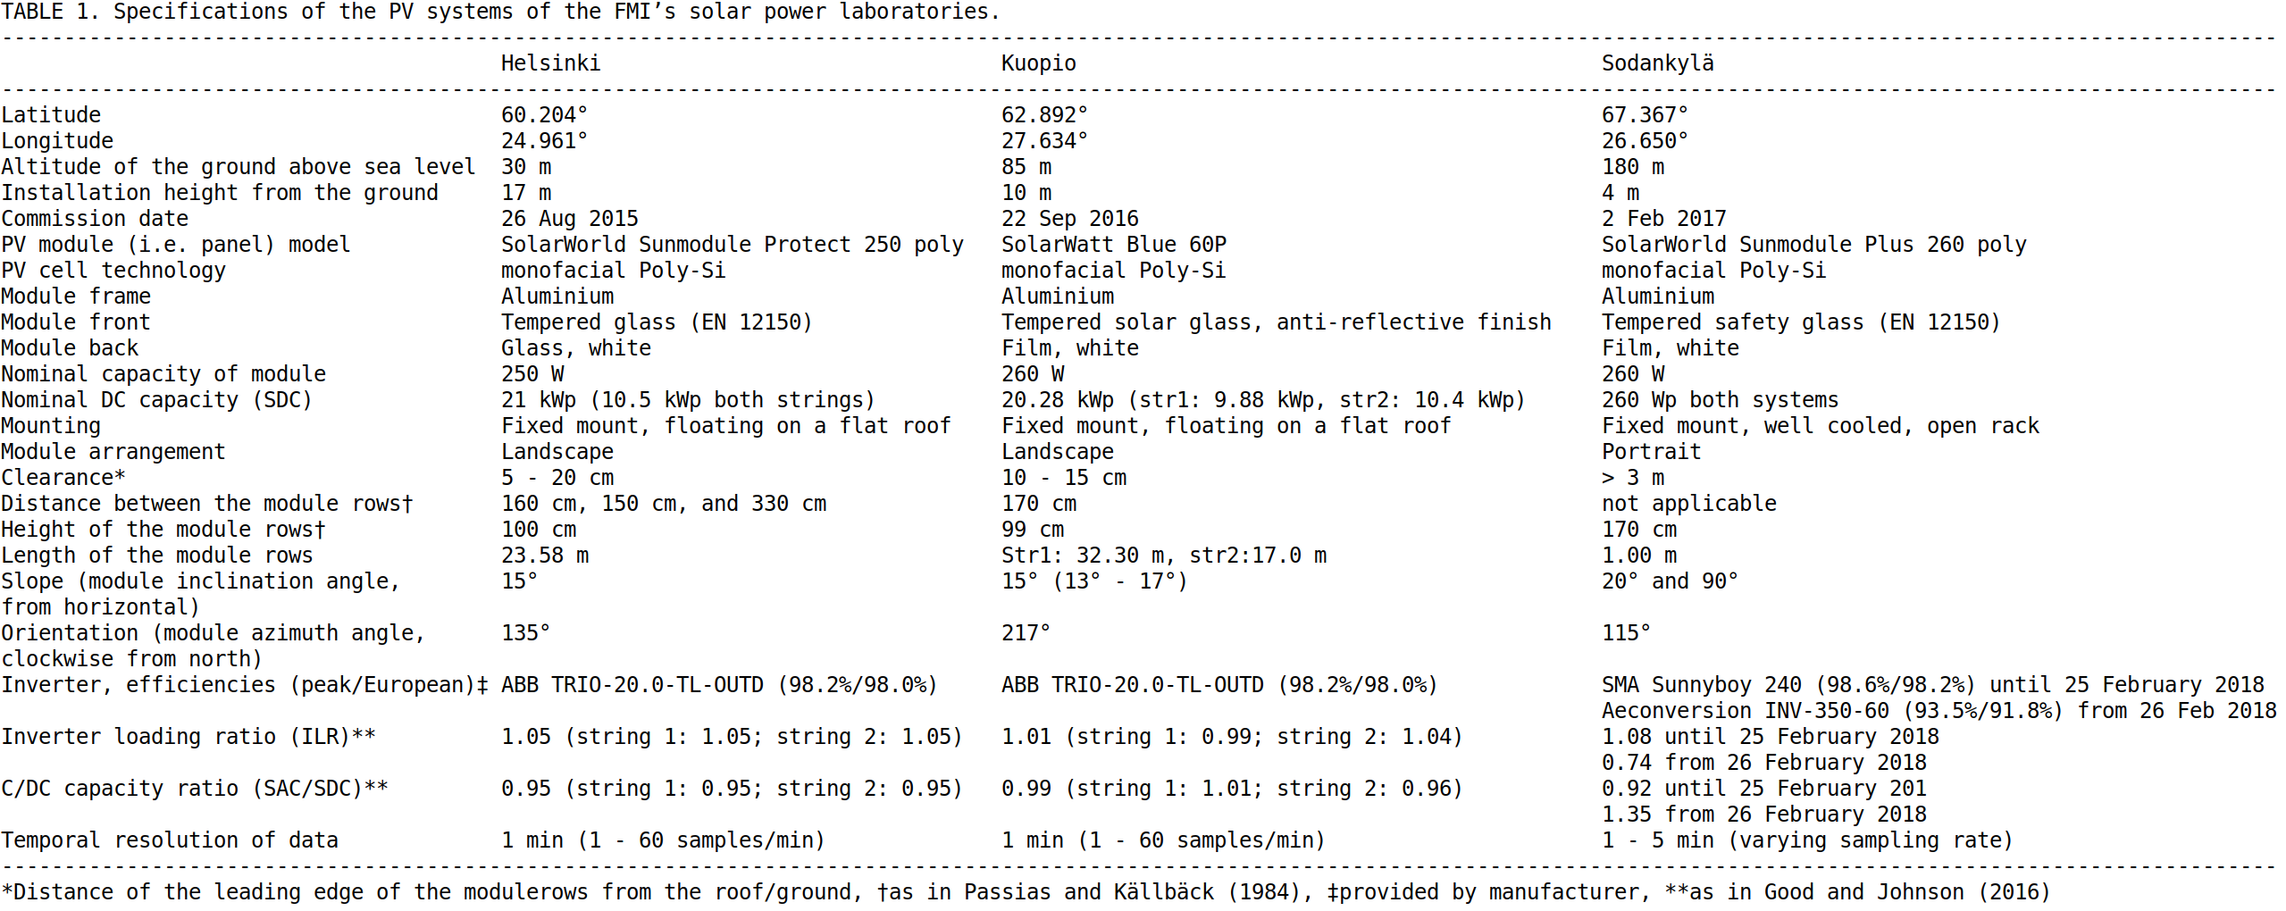

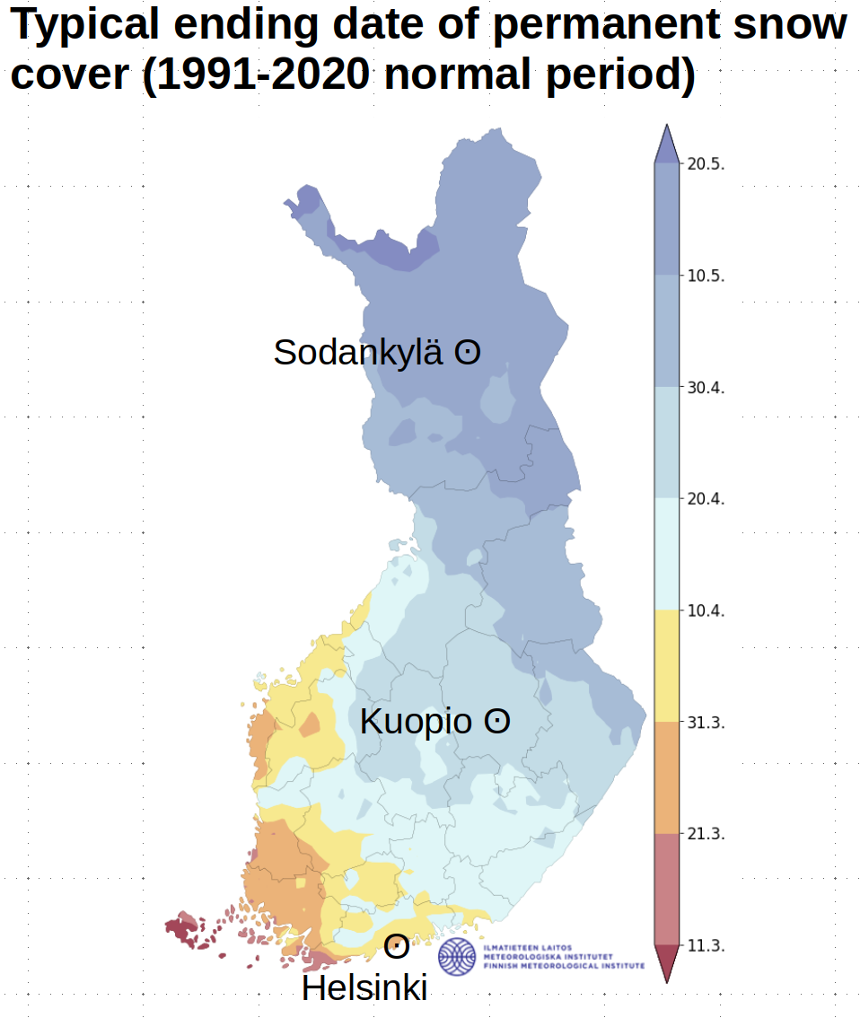

Figure 1. Locations of the open-air solar power laboratories of FMI and typical ending date of permanent snow cover (1991-2020 normal period) in Finland.

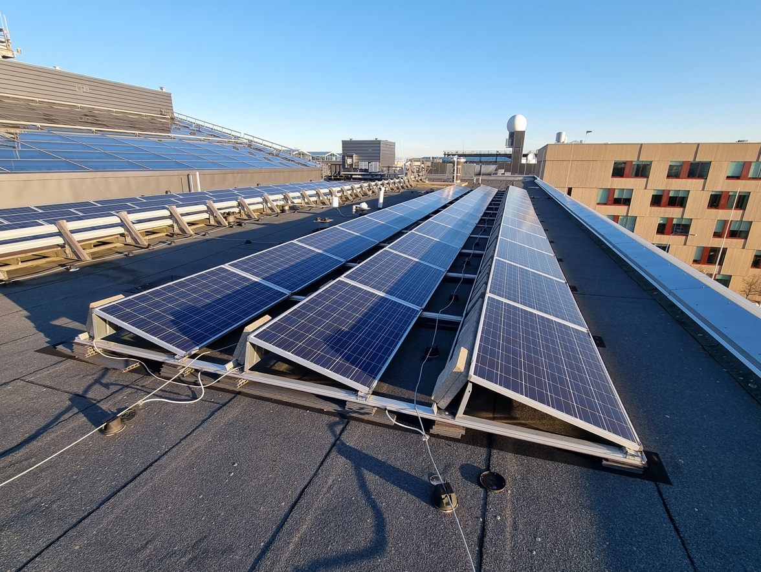
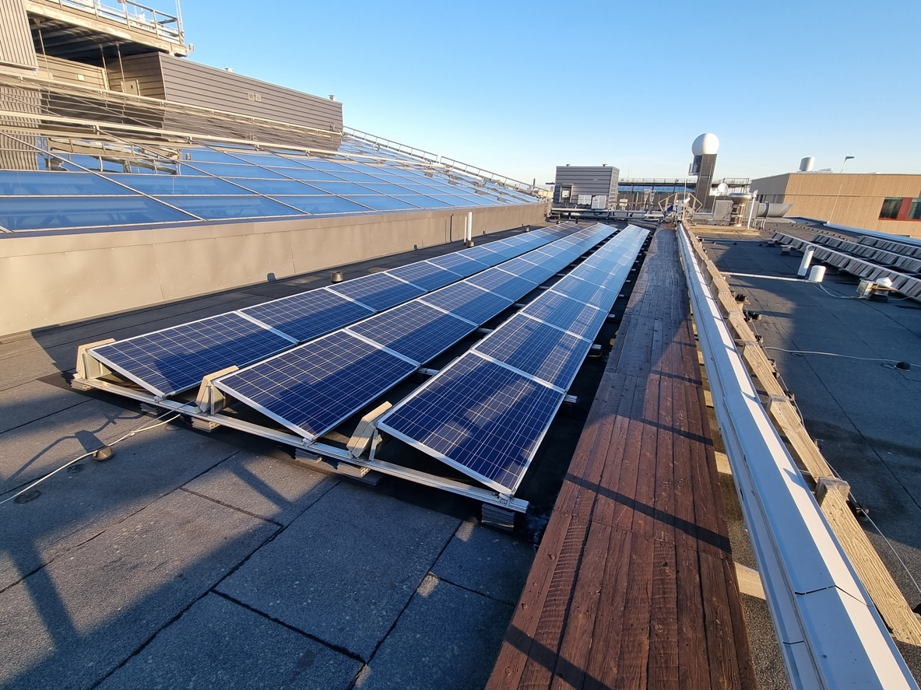

Figure 2. Helsinki PV system.
In the top image, string 2 is in the middle and string 1 on the left behind a cable rack. In the bottom image, the string 1 is in the left/middle, wooden walk-way and cable rack slightly on the right and the concrete slabs holding the modules of string 2 in place in the far right. G_{POA} pyranometer and radiation shield of air temperature sensor in between the strings is seen in both images. Self-shading caused by previous module rows enhanced by concrete slabs protruding at the ends of the module rows can be seen on the second and third module rows in both strings. Shading caused by the walkway and cable rack is visible on the first module row of string 1. The brownish school building seen in both images in the right was built in 2023 after the period under study. The top photo is taken at 10:06 and the bottom photo at 10:05 local time on 16 December 2023.

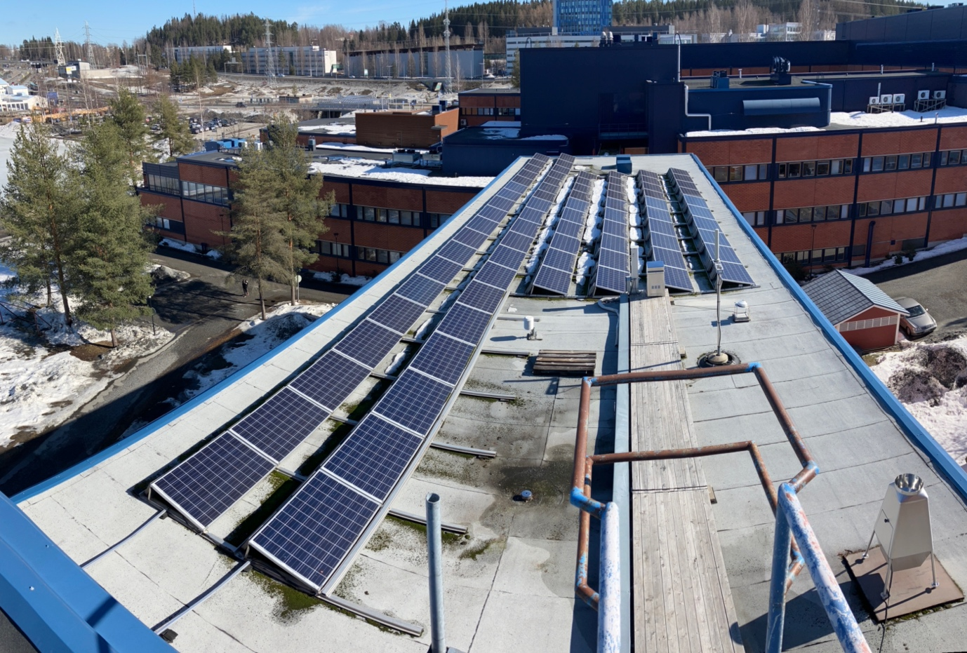

Figure 3. Kuopio PV system.
Two long module rows with 19 modules each of string 1 on the left and four shorter module rows with 10 modules each of string 2 on the middle/right. G_{POA} pyranometer to the right and radiation shield of air temperature sensor to the left of a wooden walkway. The photo is taken from an elevetad (ca. 3 m) building extension at 14:33 local time on 9 April 2024.

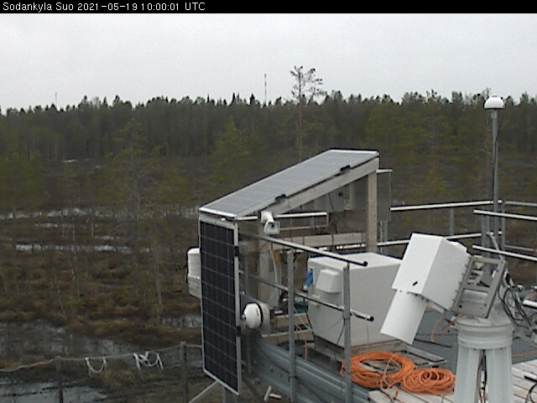

Figure 4. Sodankylä PV modules.
G_{POA} pyranometer to the right and radiation shield of air temperature sensor to the left of the 90° module. The photo is taken at 13:00 local time on 19 May 2021 by the fixed monitoring camera of the modules.

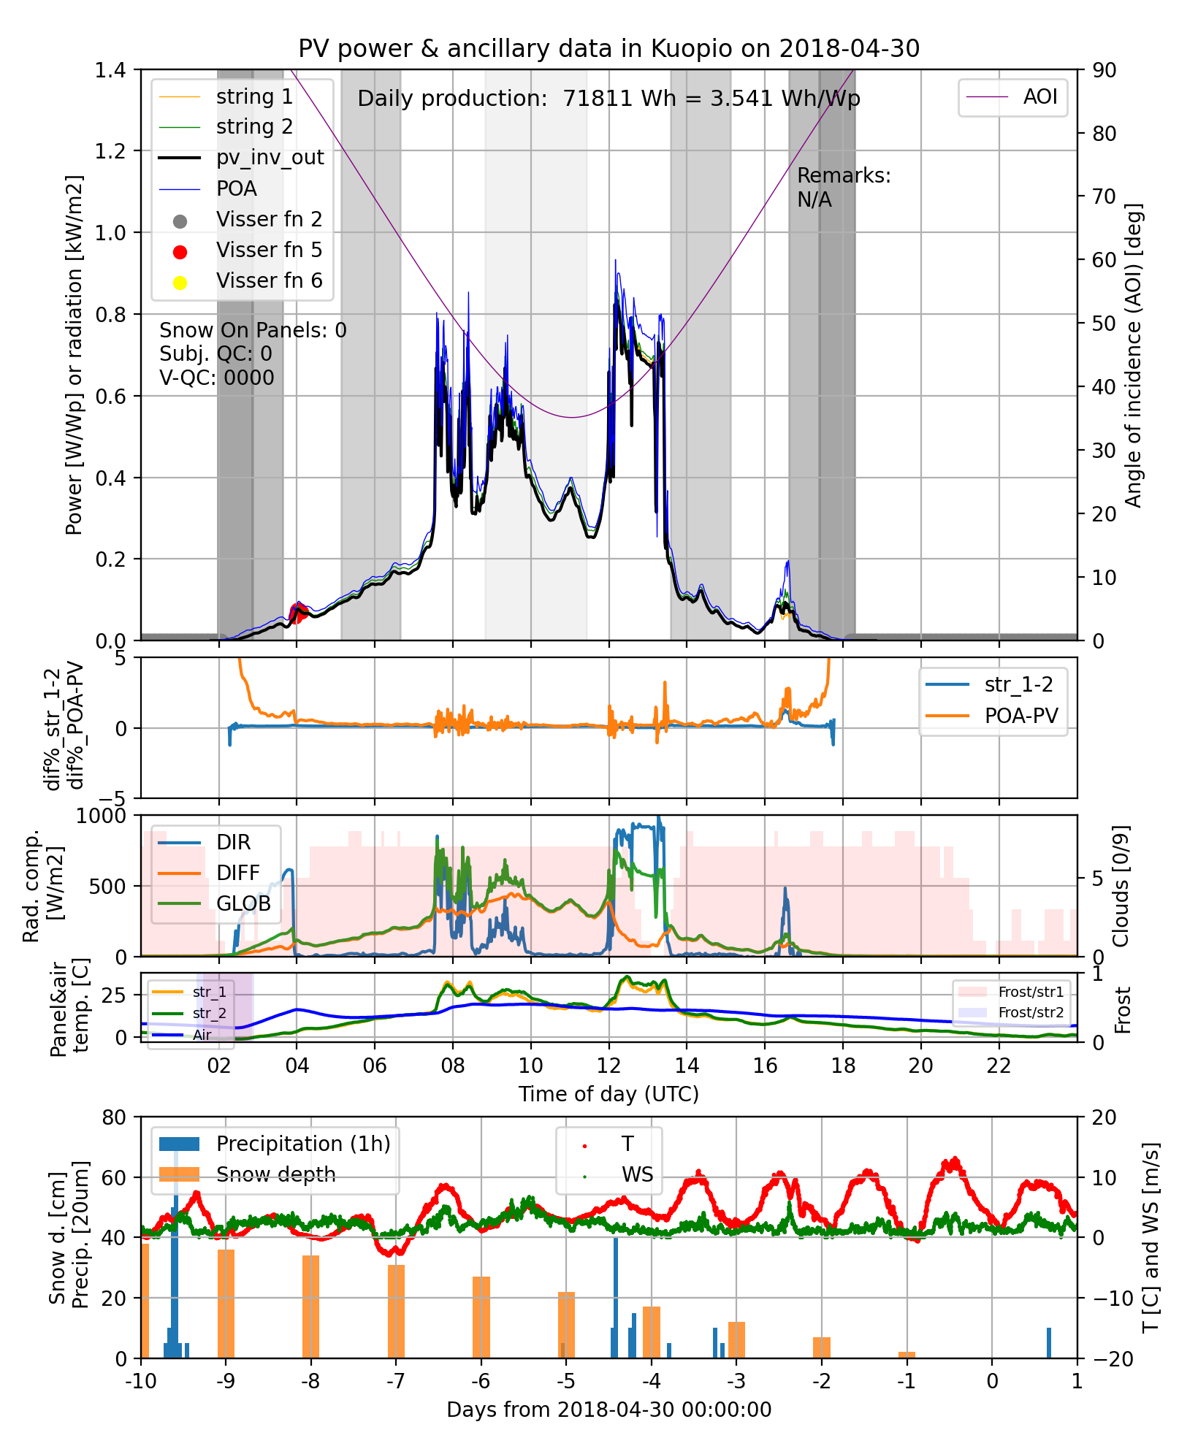Figure 5: Quality control and snow status classification graph.
In the topmost module the P^{meas} of the strings 1 and 2 (DC) and the whole PV system (AC) measured by the inverter during one day are shown along with G_{POA}^{meas}. On the AC curve, Visser QC instant filter flags are marked. On this particular case (30 April 2018 in Kuopio) the night-time (filter number 2) and upper limit (filter number 5) filters ticked. Total gross and nominal daily productions are printed on the upper middle section of the plot. The angle of incidence is shown with lila curve. The grey vertical bars with gaps in between denote SZA with 10° intervals. In the first and last grey bar the first (last) 5° are shown with the darkest shade. Below the legend box information the snow status of the modules (Snow on modules) and Visser QC daily filter tickings (V-QC) are shown. For the snow status the coding is as follows: 0 = no snow on the modules, 1 = unclear, 2 = probably some snow on the modules, 3 = probably extensively covered, and 4 = modules probably totally covered with snow. On this particular day it was inferred from the data shown in the graph, that there was no snow on the modules. For “V-QC” the coding is such that if the daily filter ticked, it is shown with it’s filter number in the four digit string. During this particular day none of the Visser QC daily filters ticked. In the second module the relative differencees between Pmeas (DC) of string 1 and 2 as well as P^{meas} (AC) of the whole PV system and G_{POA}^{meas} are displayed. The third module from the top shows the different radiation components measured near the PV system along with cloud cover information as octas of the sky. Number 9 in the cloud cover coding is reserved for missing data. The fourth module shows the measured module temperatures and air temperature measured beside the module field. The calculated occurrence of frost conditions for each module is shown, too. The lowermost module shows the evolution of precipitation, snow depth, wind speed and temperature for the day in question (0 - 1) and 10 days before (-10 – 0) measured by the near by FMI weather station.

Table 2. Annual number of days of PV systems in each snow status category
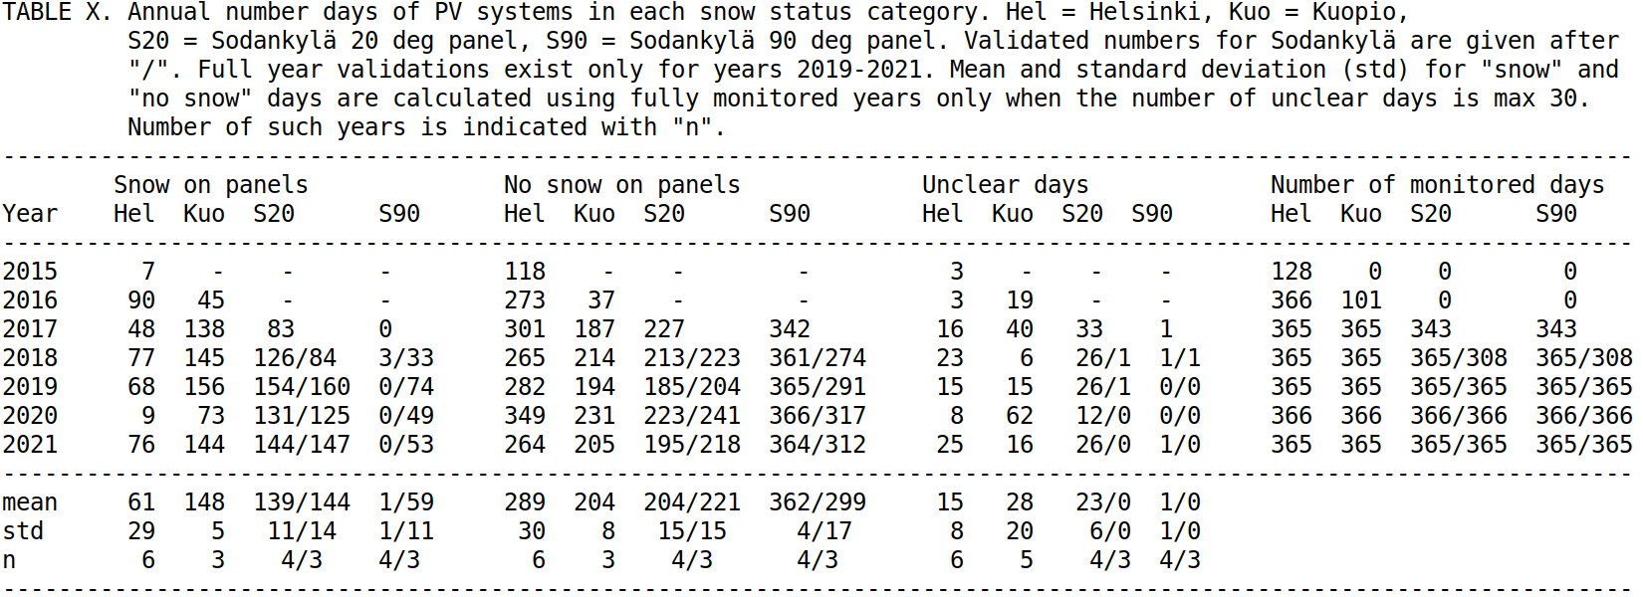

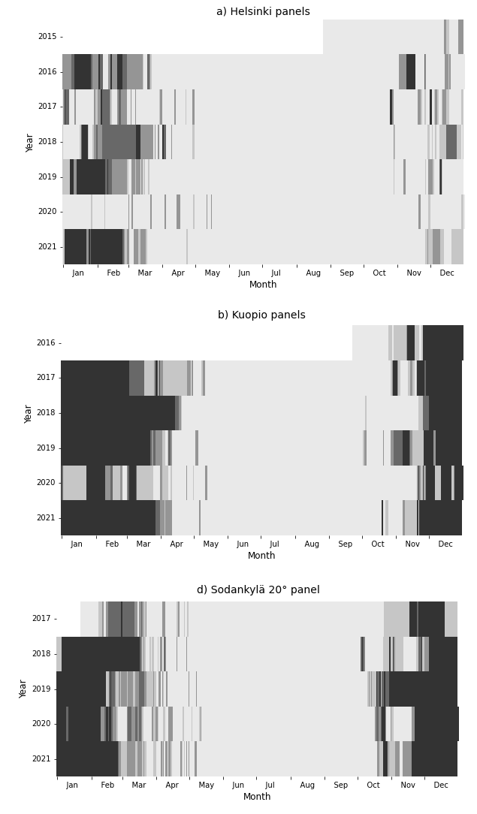

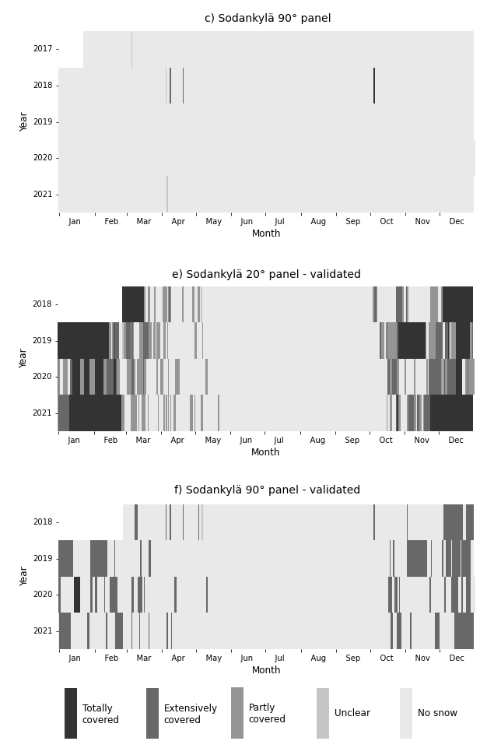

Figure 6. Daily snow status of the PV systems.
In plots a)-d) the daily snow status of the FMI PV systems inferred from the visual inspection of the PV, ancillary and meteorological data (as in Fig. 3) are presented. In plots e) and f) the Sodankylä results of classification based on camera images are shown.

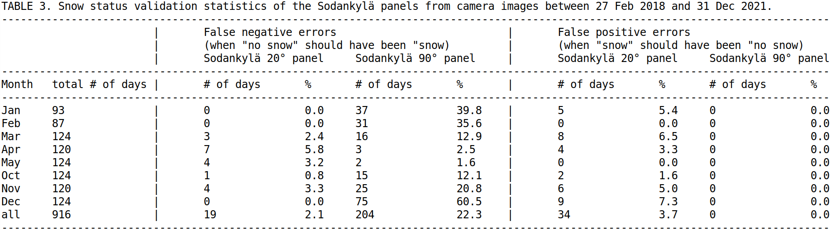

Table 3: Snow status validation statistics of the Sodankylä modules between 27 Feb 2018 and 31 Dec 2021.

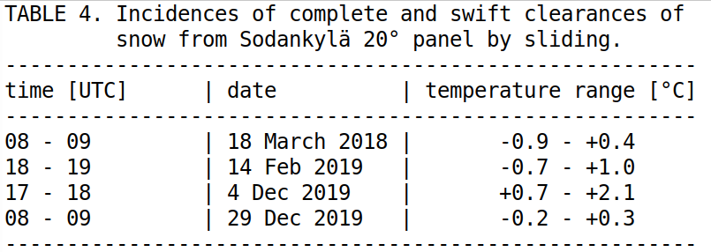

Table 4. Incidences of complete and swift clearances of snow.
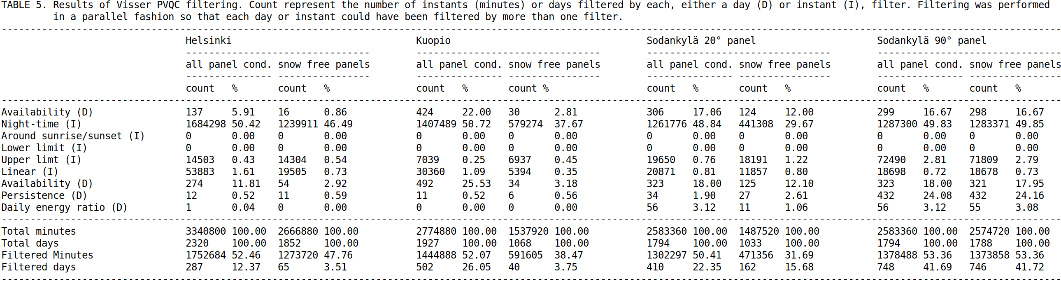

Table 5. Results of Visser PVQC filtering.

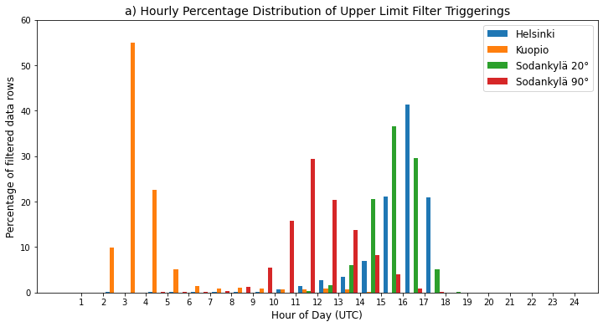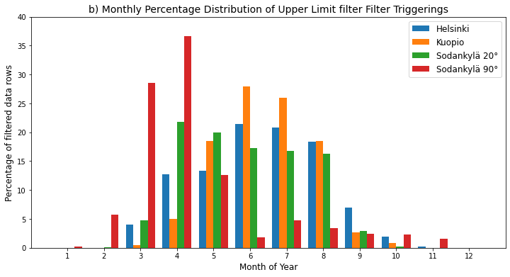Figure 7. Distribution of Visser PVQC upper limit filter triggerings
The hourly distributions of Helsinki, Kuopio and Sodankylä 20° module show strong distortion towards high SZA when the modules are facing away from the Sun. For Sodankylä 90° module, the distributions are pronounced during noon (a) and spring months (b).

Table 6. Annual output of the PV systems
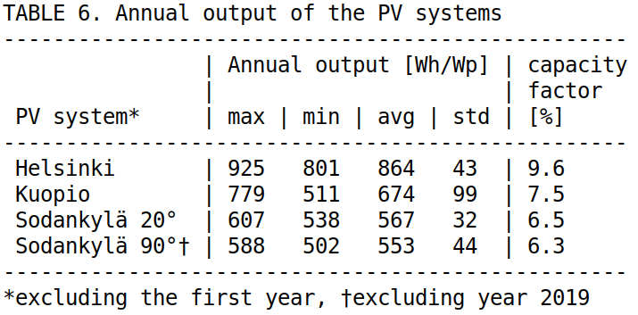
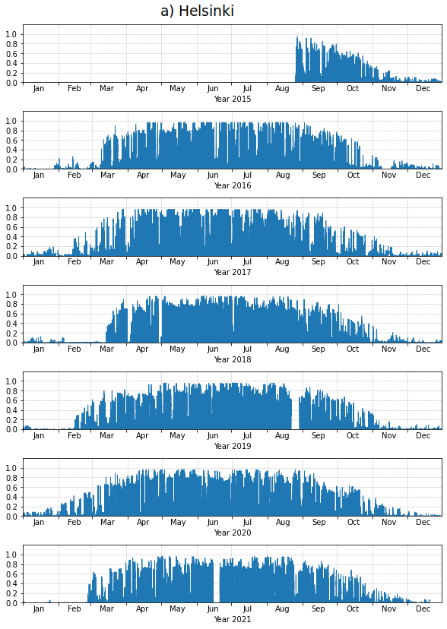

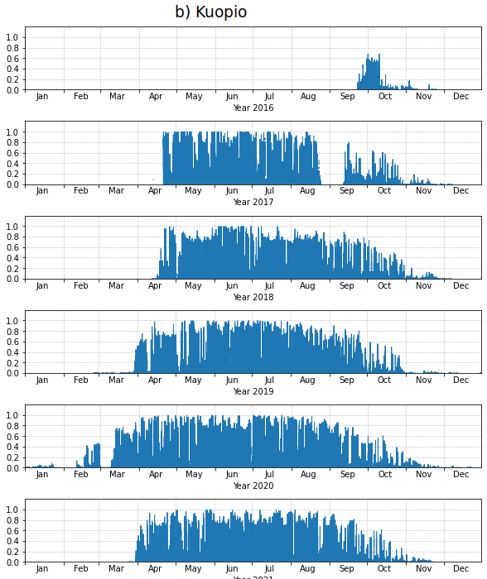

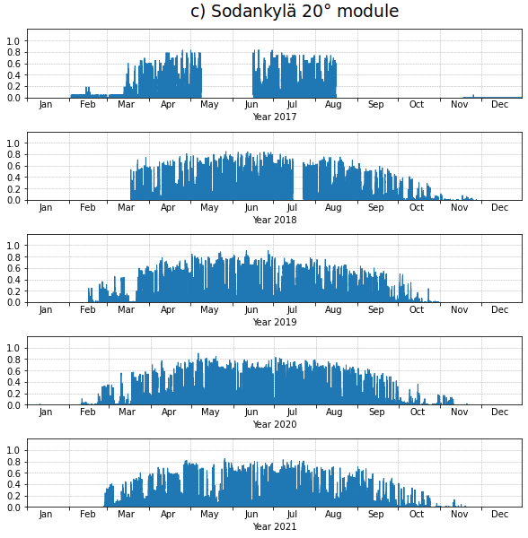

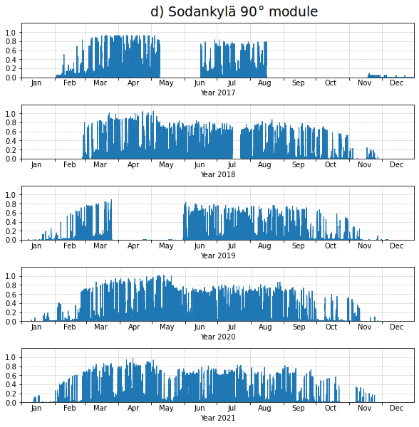

Figure 8. Nominal power output of the FMI PV systems
Instant power in 1 minute resolution for all FMI PV systems a) Helsinki, b) Kuopio, c) Sodankylä 20° module and d) Sodankylä 90° module) from the commissioning until 31 December 2021.
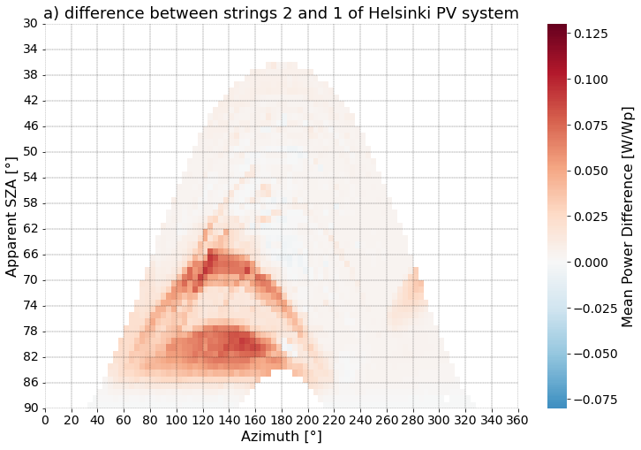
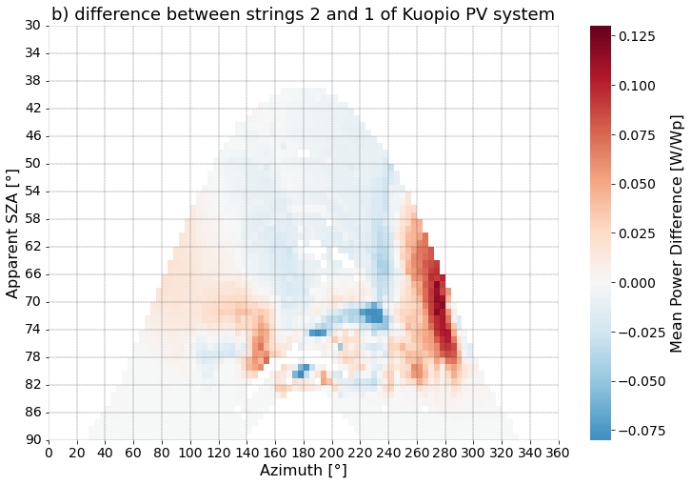

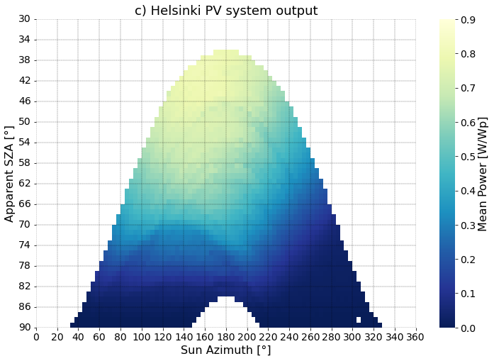
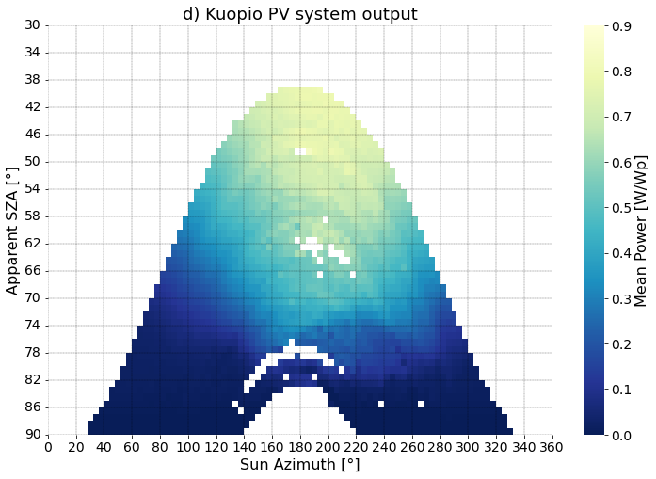
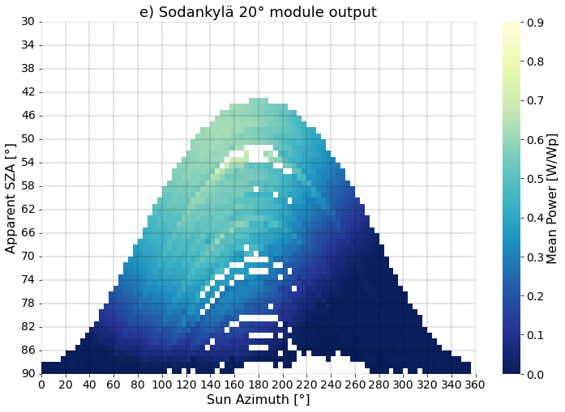
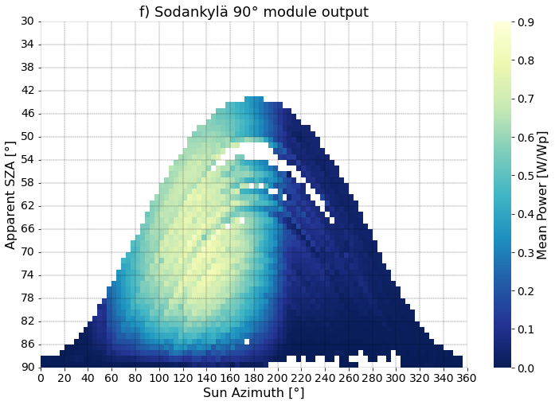
Figure 9. Average P^{meas} as a function of sun position
The mean output values from the commission until 31.12.2021 were calculated from data of snow free modules for moments when beam radiation is 10 times stronger than diffuse radiation (DNI > 10*DHI) in order to highlight the shading patterns. 1 min time resolution within bins of 1° sun elevation and 4° sun azimuth was used. In a) and b) the difference between the two strings is presented for Helsinki and Kuopio, respectively. In subfigures from c) to f) are the mean output values for Helsinki, Kuopio, Sodankylä 20° and 90° PV systems.
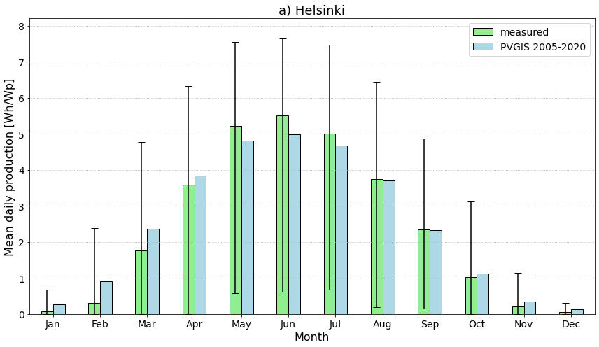
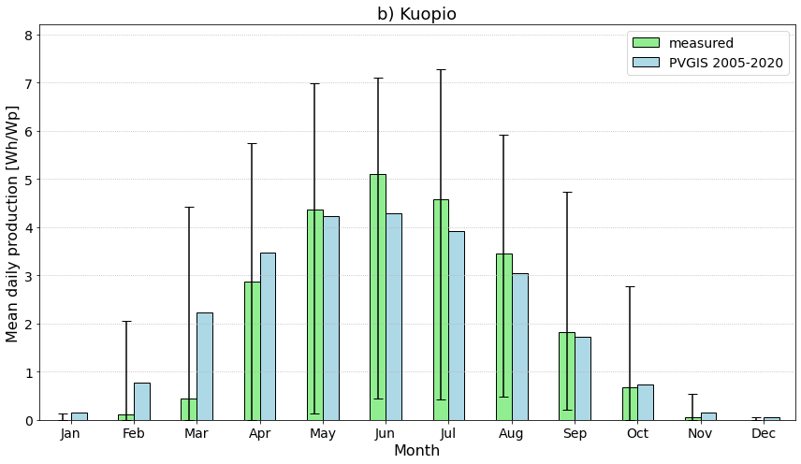

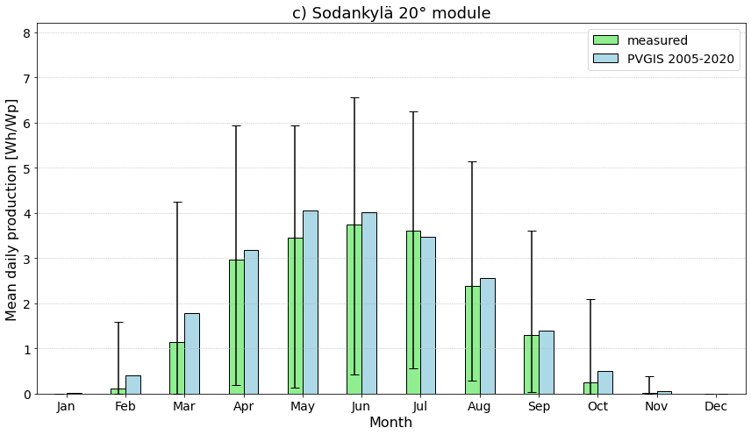
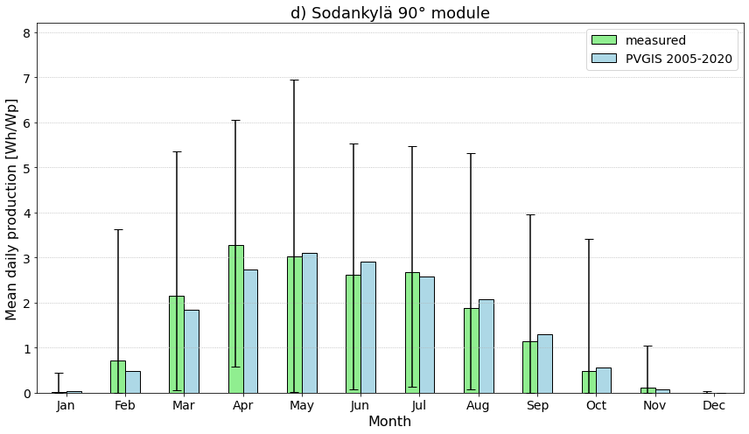
Figure 10. Daily averages of PV production by month
The bars represent the range of daily values measured in each month. The days with inverter clipping incidences in d) have been filtered out. As comparison, modelled climatological production with PVGIS tool (system loss of 14 % and ERA5 as radiation data source) is shown.

Supporting information

S1: Nomenclature
Acronyms
AC | Alternating current
AM | Air-mass
AOI | Angle of incidence
AWS | Automatic weather station
CE | Cloud enhancement
DC | Direct current
DER | Daily energy ratio
ECMWF | European Centre for Medium-Range Weather Forecasts
ERA5 | ECMWF Reanalysis v5
FMI | Finnish Meteorological Institute
METIS | FMI’s Research Data repository
MPP | Maximum power point
POA | Plane-of-array
PV | Photovoltaic
PVGIS | Photovoltaic Geographical Information System
QC | Quality control
STC | Standard test conditions
Wp | Watt-peak
Symbols
Az (°) | Solar azimuth angle clockwise from north
$G_{POA}$ | POA global irradiance
$$GHI\left(Wm^{−2}\right)$$ | Global horizontal irradiance
$$DHI\left(Wm^{−2}\right)$$ | Diffuse horizontal irradiance
$$DNI\left(Wm^{−2}\right)$$ | Direct normal irradiance
$$E_{o}=1367Wm^{−2}$$ | Solar constant
$$E_{ext}\left(Wm^{−2}\right)$$ | Extraterrestrial irradiance on a horizontal surface
 | Latitude
 | Longitude
$$T\left(℃\right)$$ | Temperature
$$W\left(ms^{−1}\right)$$ | Wind speed
$$P$$ | PV power
$$S$$ | Capacity
$SZA$ (°) | Solar zenith angle
t | time
Hz (1/s) | Herz
Subscripts
cs | clear-sky
mod | module
amb | ambient
as | all-sky
ext | extraterrestrial
Superscripts
est | estimated
meas | measured
' | Variable normalized to STC

S2: The Visser PVQC filter equations
1. The first filter in the PVQC is a day filter and examines the proportion of the measured PV power values ($P^{meas}$) available. During a given day and for solar zenith angle smaller than 85° $SZA<85°$, if the ratio between the number of $P^{meas}$ available and the number of minutes theoretically available, is lower than 0.5, the entire day is not retained for further analysis.
2. The second filter is an instant filter and sets all $P^{meas}$ to zero during nighttime as usually no electricity production is expected from any PV system. This night-time filter involves comparison to estimated clear-sky PV power denoted as $P_{cs}^{esti}$ computed with the simplified version of the Solis clear-sky model from the ”pvlib python” library (Holmgren et al., 2018). In the Visser PVQC, $P_{cs}^{esti}$ varies based on location, time and maximum module (direct current, DC, Wp) and inverter (alternating current, AC) capacities. This filter # 2 is mathematically defined as follows:
$P_{cs}^{est}\left(t\right)≤0⟹P^{meas}\left(t\right)=0$ (1)
3. The third filter is an instant filter that sets negative values to zero around sunrise and sunset and is mathematically expressed as follows:
$P^{meas}\left(t\right)<0,∨t≤\left(t_{sunrise}+30min\right)∨t≥\left(t_{sunset}−30min\right)⇒P^{meas}\left(t\right)=0$ (2)
4. The fourth filter is an instant filter and sets negative values to NaN during daytime.
$P^{meas}\left(t\right)<0⇒P^{meas}\left(t\right)=NaN$ (3)
5. Unrealistic high values may occur during the daytime in some circumstances. Therefore, an upper limit is set and applied. The fifth filter, also called the upper limit filter is an instant filter and divided into two sub-filters using nominal AC and DC capacities noted $S_{AC}$ and $S_{DC}$ respectively. The first one sets $P^{meas}$ to NaN if it exceeds $S_{AC}$ of a given PV system by 2.5%. It is mathematically defined as follows:
$P^{meas}\left(t\right)>1.025S_{AC}⟹P^{meas}\left(t\right)=NaN$ (4)
The second sub-filter of the upper limit filter involves $P_{cs}^{esti}$ as previously defined in the second filter. Here, the acceptable upper limit takes into account effects from cloud enhancement (CE). The upper limit is empirically defined as $P_{cs}^{esti}$ multiplied by a cloud enhancement coefficient set to 1.4. The filter sets P^{meas} exceeding the acceptable limit to NaN for $SZA<80°$.
$P^{meas}\left(t\right)≥1.4P_{cs}^{esti}\left(t\right)⟹P^{meas}\left(t\right)=NaN$ (5)
For higher zenith angles or lower sun, i.e. SZA>= 80°, more relaxed criteria are used, and the sub-filter here is expressed as follows:

$P^{meas}\left(t\right)≥1.4P_{cs}^{esti}\left(t\right)∧P^{meas}\left(t\right)>0.125S_{DC}∨twhere80°≤SZA<85°⟹P^{meas}\left(t\right)=NaN$ (6)

$P^{meas}\left(t\right)≥1.4P_{cs}^{esti}\left(t\right)∧P^{meas}\left(t\right)>0.075S_{DC}∨twhereSZA≥85°⟹P^{meas}\left(t\right)=NaN$ (7)

6. The sixth filter is an instant filter, also called the linear filter. It aims to identify temporary failure of the data logger showing for instance constant, or linearly increasing/decreasing $P^{meas}$ during a given period of at least 20 consecutive minutes. This linear data filter is applied for $SZA<85°$ and it sets $P^{meas}$to NaN in case the $P^{meas}$ feature a constant or linearly increasing/decreasing value. The filter #6 is mathematically defined as follows.
$\frac{∂P^{meas}}{∂t}=c,∀t∈\left\{t,t−1,…,t−19\right\}∧SZA<85°⟹P^{meas}\left(t\right)=NaN$ (8)
7. The seventh filter is a repeat of the first filter after the application of the instant filters 4, 5 and 6, which have reduced the availability of good data points possibly below the threshold, 50%.
8. The eighth filter is a day filter, also called the persistence filter. It filters the entire day if the power output variability is extremely low or high. The persistence filter is applied for $SZA<80°$. It involves comparison to extraterrestrial irradiance.
$\frac{1}{8}μ\left(\frac{\frac{P^{meas}}{S_{DC}}}{E_{ext}}\right)≤σ\left(\frac{\frac{P^{meas}}{S_{DC}}}{E_{ext}}\right)≤τ$ (9)
where $μ$and $σ$represent the mean and standard deviation, $E_{ext}$is the extraterrestrial solar radiation on a horizontal surface obtained with the pvlib package and $τ$is a constant set to 0.35.
9. The ninth filter is a day filter, also called the daily energy ratio (DER) filter and it analyses the DER noted as $r_{de}$ of a given day $d$. It involves comparison across independent PV systems in the same area. In our case, the independent systems in Helsinki and Kuopio were the two independent strings of a single PV system and in Sodankylä the two independent modules. The DER filter calculates a daily ratio of measured PV energy and estimated clear-sky energy for each system in the same area. For a given day $d$, if the daily ratio of a given system $i$ noted as $r_{de,i}$ deviates more than 0.25 from the mean of daily ratios for all PV systems, the entire day of that given system is removed from further analysis. The filter # 9 is mathematically defined as follows.
$r_{de}\left(d\right)=\frac{\sum_{t=1min}^{1440min}{P^{meas}\left(t\right)}}{\sum_{t=1min}^{1440min}{P_{cs}^{esti}\left(t\right)}}$; $\left|r_{de,i}\left(d\right)−\frac{\sum_{i=1}^{n}{r_{de,i}\left(d\right)}}{n}\right|≥0.25$ (10)

where $n$ represents the number of independent PV systems of the area. The Visser PVQC gives an option to normalize the daily energy ratio with the maximum DER. We chose not to normalize as the maximum DER for Sodankylä 90° module was infinity. This happened when the clear-sky model estimated zero production during polar night, but the PV system with a fresh module and a SMA microinverter still produced electricity during some days in December 2017.

S3: Visser PVQC filtering: results and evaluation in detail
The filtering results of Visser PVCQ are presented in Table 5 and summarized in chapter 2.3.2 of the article. Here we give a detailed treatment of the results and findings.
Filter 1: availability filter
In the Visser PVQC, the first filter applied is the availability filter. The biggest share of filtered days, 22.00%, is found in Kuopio and the smallest, 5.91%, in Helsinki when considering both snow-free and snow cover conditions (all module conditions). The filter correctly detected the missing data of Helsinki on 7 Sep 2017, 8 Sep 2017, 15 Nov 2017, 29 Apr 2018, and 30 Apr 2018 (unknown problem), 22-29 Aug 2019 (except for the last day, possibly a communications problem), and 20-31 Dec 2021 (except for the first day, an unknown inverter problem).
In Kuopio, the availability filter flags all days between 8 Jan 2017, when the sun starts to properly rise above the horizon (SZA < 85°) and 21 Apr 2017. We suspect that this is at least partly due to a PV-system “wake-up” problem seen in Kuopio during all springs 2017-2021. The cause of the problem is not known, although, it could be speculated that e.g. resistance leakage might explain the phenomenon. The problem coincides the time of the year when cables and junctions are exposed to excess moisture and water from melting snow. Spring 2017 is an extreme case of the “wake-up” problem as the PV-system shows very little signs of activity during the winter before waking up properly on 21 Apr 2017. Determining the start date of the Kuopio “wake-up” problem in winter 2016 - 2017 is complicated by the fact, that at that time zero P^{meas} values, that would give indication of some radiation reaching the modules, were filtered out by the sampling system. The change in the sampling system in Kuopio was implemented only on 19 Sep 2017. The module temperature measurements, that indicate an exposed module surface, started on 16 Feb 2017. The peak snow depth (59 cm) according to the nearby automatic weather station (AWS) occurred on 25 Feb 2017. The first sign of exposed modules after peak snow depth occurs on 3 Mar 2017 when the module temperature values deviate. On four occasions after that (23, 24, and 31 Mar as well as 13 Apr 2017) there is minimal output giving evidence that enough of module surface is exposed for production to happen. Due to these facts the Kuopio PV-data between 28 Nov 2016 and 21 Apr 2017 is considered either erroneous or possibly erroneous. An accurate and validated snow accumulation model combined with a PV model fine-tuned for the Kuopio PV system would be required to definitively estimate the quality of the PV data during winter 2016 - 2017.
There was a period of frequently, either intermittently or totally, missing PV-data during 9.7. - 21.9.2017 in Kuopio. Of the 75 days during that period, 27 were filtered by the availability filter indicating at least 50% share of missing data during that specific day. 40 days had gaps amounting to less than 50% of the PV data points during daytime and 8 days (9, 11, and 21 Aug, and 13, 14, 15, 16, and 18 Sep) were totally without missing data. Based on the fact that the existing PV data, when compared with the POA measurements during that period, seem to be of good quality, the gaps are possibly due to some kind of sampling or communications issue and the existing data can be used for model validation, for example.
In Sodankylä, the availability filter correctly detects that data are missing from both the 20° and 90° module PV-systems (probably due to communications error ) between 9 May and 15 June as well as 16 August and 11 November 2017 but fails to detect the last days (12 to 17 November 2017) of the second stretch of missing data. This failure is due to the SZA < 85° cut-off limit of the filter. The PV systems are seemingly performing correctly at least until 22 December 2017, when the last correct data from the 90° module is recorded. After that until 7 January 2018, the PV data quality is uncertain. Starting from 8 Jan until 26 February 2018 the PV data is missing due to an unknown malfunction. Of this stretch of missing PV data, the availability filter correctly detects the part falling within its operating range 30 Jan – 26 Feb 2018 but fails to detect the earlier part of the stretch.
The availability filter correctly detects the missing data of the 90° module on 5 and 6 March 2018. It also correctly detects the missing data of the 90° and 20° modules during 15 – 23 July 2018, except for the first day, 15 July 2018.
There was a sudden drop of solar radiation on 15 July 2018 at 12:32 UTC due to extremely heavy thunderstorm (clouds and rain) blocking virtually all radiation entering the instruments and PV-modules. PV-data goes to NaN at 13:08. According to the FMI’s lightning detection system, there was a lightning at 13.07:36 UTC 1.2 km from the PV system. The PV-data does not recover until 23 July 2018, so most probably something got broken in the PV-system due to that particular lighting and the fixing took eight days.
The availability filter correctly detects the missing PV data of the 90° module during 26 March – 30 May 2019 and 23 October – 6 November 2021. The 26 March – 30 May 2019 stretch of missing 90° module data has a striking feature in that in the midst of days of totally missing data there are a few days (19, 23, 24 25, 29 April and 9, 17, 18, 19, 20, 23 May) when there are either a few single datapoints available or just a very small stretch of data. In all these cases the available data appears late in the afternoon when the hours of the highest radiation have already passed.
All in all, majority of the cases flagged by the availability filter are in all sites caused by such a low irradiation reaching the modules (either due to snow on the modules and/or heavy overcast conditions combined with high SZA) that the inverter did not receive enough input to produce any readings. This is reflected by the fact that the shares of filtered cases drop drastically to 2.81% in Kuopio and to 0.86% in Helsinki when considering only snow-free module conditions. In Kuopio, there are 37 days, and in Sodankylä, there are 80 days during midwinter when the minimum SZA > 85°, which are out of the working range of the availability filter.
Filter 2: night-time filter
The percentage of filtered minutes out of the total minutes range from 50.42% for the Sodankylä 20° module to 52.46% for Helsinki when considering all conditions (both snow-free and snow cover conditions). Majority of the filtered rows are a result of the night-time filter. When considering only snow-free conditions (summertime) the percentage drops going from south (47.76% in Helsinki) to north (31.69% for the Sodankylä 20° module) reflecting the midnight sun conditions of northern latitudes. The high percentage of filtered minutes for the Sodankylä 90° modules during snow-free conditions is a result of the vertical module seeing only half of the sky and thus, according to the clear-sky model, receiving too little radiation to produce power.
Filters 3 and 4: around sunrise/sunset and lower limit filters
The around sunrise/sunset and lower limit filters are not triggered for any of the systems at any time. We regard this reasonable as we cannot think of any physical cause for a PV system producing negative values under any conditions. For irradiance measurement devices such as pyranometers, on the other hand, negative values are physically possible although not realistic (Add reference?!). As Visser et al. (2022) report, some inverters can give erroneous (negative) readings of the input and/or output, but for the inverters used in FMI sites, this has not happened.
Filter 5: upper limit filter
The upper limit filter is triggered in all four PV systems. The amount and distribution of upper limit filter triggerings may have been affected somewhat due to inverter clippings. The smallest share of triggered minutes for all module conditions is found in Kuopio (0.25%) and the greatest share in Sodankylä 90° module (2.81%). Nevertheless, we did not find any credible case of actual system performance fault as a cause for filtering. In all studied cases, the G_{POA} showed similar features (spikes) as P^{meas}. Instead, we suspect that the upper limit filter is triggered mainly due to larger than allowed cloud enhancement (CE) and, for the Sodankylä 90° module especially, snow reflection. The distribution of the triggered cases shows major distortion towards high SZA, when the modules are facing away from the Sun (early morning for Kuopio or late evening for Helsinki and Sodankylä 20° module) (Figure 5a) and summer (Figure 5b) in all the sites except for the Sodankylä 90° module for which the peak number of cases are found during lower SZA (around noon) and spring. Therefore, we conclude that the Visser PVQC upper limit filter is too strict, and FMI’s real data (P^{meas}) is reasonable even with stronger CE than 1.4. Stronger CE is typical when sun is low and cloud fraction > 4/8 (Piedehierro et al. 2017, Gueymar 2014, Pecenak et al. 2016). Although not proved, it seems very plausible based on FMI’s data that inclined planes have stronger CE compared to CE in horizontal irradiance, and this is seen in particular for cases when the inclined plane is facing away from the sun (or at least not towards the sun). Therefore, an improvement of Visser's algorithm will require to include an CE depending on SZA/AOI for low Sun(?) along with an algorithm that takes the reflection from snow into account better than the current clear-sky model.
Filter 6: linear filter
The linear filter is triggered multiple times in all four PV systems. The smallest share of triggered minutes for all module conditions is found for the Sodankylä 90° module (0.72%) and the greatest share in Helsinki (1.61%). In all the Helsinki and Kuopio cases the triggering was caused by zero P^{meas} values. The linear filter correctly detected the malfunctioning of the Helsinki inverter due to burned fuses during 15 – 21 June 2021 and erroneous zero data in Kuopio on 7 May 2020 and 24 – 25 September 2020. The majority of the cases were nevertheless erroneously caused by such a low irradiation reaching the modules either due to snow on the modules and/or heavy overcast conditions combined with high SZA, that even though the inverter received DC input it was not enough to produce output. From our viewpoint, all these cases represent correct performance of the PV systems with specific characteristics of the site (large share of overcast conditions, snow cover, and high SZA hours combined perhaps with less than best inverter efficiency). Thus, these cases should not be filtered out. Nevertheless, the cases described above related to low irradiation conditions bear certain similarities to erroneous function of the PV-system (either some module component or the inverter) in Kuopio during all springs 2017 – 2021. The error occurs when the PV-system for an unknown reason has difficulties to wake up properly. Characteristics of this error are constant and intermittent zero inverter DC input and AC output (P^{meas}) values with rapid variability during early hours of the day while G_{POA} would allow for fair amount of output (Figure SOX1). The linear filter correctly detects the constant zero parts of the error, but the intermittent part is not detected by any of the filters. Characteristic features for this error are also that there are days with no error in between the erroneous days and that there can be seemingly good datapoints before the intermittent error occurs. There were 101 days with this issue identified during spring 2017, 10 days in 2018, 7 days in 2019 and 37 and 15 days in 2020 and 2021, respectively. A separate list of the days is provided in the supporting information “S04_List_of_Kuopio_wake-up_prob_days.csv“. In most cases, with the notable exception of year 2017, the “wake-up problem” has only a small effect on the total energy output of the day and the PV data outside the “wake-up problem” times are considered reliable. When calibrating/fitting PV model for the data these errors should always be considered.
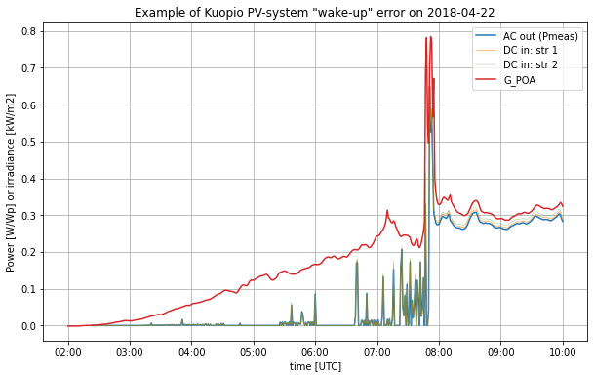Figure SO1. Example of Kuopio PV-system wake up error on 2018-04-22. G_{POA} rises almost monotonously during early hours while all P values (DC string 1 and string 2 inverter inputs and AC inverter output) show erroneously zero and rapidly varying and mostly lower than expected values until c. 7:50 after which the G_{POA} and P variability are aligned. All the modules are inferred to be snow free for the whole day. The Visser PVQC linear filter correctly detects the constant zero power values around 5 UTC and after 6 UTC.
In the Sodankylä PV lab, the linear filter only ticks during 2017. This reflects the 5 min actual time resolution and 12 W power resolution of the SMA SunnyBoy 240-10 microinverters used during 2017. The linear filter detects nearly all (22/25) inverter capping (clipping) incidences of the 90° module during spring 2017. The capping incidences are a result of the modest 240 W AC capacity compared to the 260 W DC capacity i.e. high inverter loading ratio (ILR = 1.08) and high incident radiation during clear sky or CE conditions accompanied with low temperature (< 5° C) providing high efficiency of the module and fresh snow providing high reflectance from the ground.
Although not as clearly, also the Helsinki and Kuopio PV systems suffer from inverter capping especially during summers of the first years of operation. These capping incidences were not identified by any of the Vissepr PVQC filters. In 2016 and 2017 in Helsinki and 2017 and 2018 in Kuopio the peak nominal power (output) seems to be limited by inverter capacity much more often than during 2020 and 2021 (Figures 15a and b). This is expected as module degradation attenuates the effect of inverter capping over time (Good and Johnson, 2016).
The capping incidences and module degradation are not erroneous readings, but expected performance of the PV system that need to be taken in to account when analysing or using the data. They are not analysed quantitatively in this study.
Filter 7: availability filter applied second time
The previous three filters are instant filters and they set erroneous P^{meas} datapoints to NaN. Therefore the availability filter is applied again in the Visser PVQC routine to remove the days where the share of data has dropped below the threshold. Nevertheless, as explained above, we do not see these instant filters filtering any true erroneous readings from the data of the FMI’s PV-systems. Therefore, the treatment of the additional filtered days; 137 in Helsinki, 68 in Kuopio, 17 for Sodankylä 20° module and 24 for Sodankylä 90° module, is omitted here.
Filter 8: persistence filter
The persistence filter is triggered in all four PV-systems: 12 days in Helsinki, 11 days in Kuopio, 34 days for the Sodankyla 20° module and 432 days for the Sodankylä 90° module. For 11/12 cases in Helsinki, 3/11 cases in Kuopio and 1/34 cases for the Sodankylä 20° module the filter ticks for too low variability. The filter seems too sensitive as the PV data is good for all, except for two, of those days. A possible reason could be the characteristically low variability of irradiance on clear sky (Figure SOX2a) and overcast (Figure SOX2b) winter days, both typical in high latitudes of Finland. The case is different to lower latitudes (Belgium (Journee and Bertrand 2011), Holland (Visser et al. 2022)) where the filter was first developed and tested for PV. Another factor is also that just outside polar night the time window for the filter to calculate variability is very short.
There were two days where the persistence filter detected genuine problems in the data. Those were 13 April 2017 in Kuopio and 6 October 2018 in Sodankylä for the 20° module, with only three (Kuopio) and one (Sodankylä) PV-datapoints for the whole day. These days were detected earlier by the availability filter as well.
There were 1/12 days in Helsinki (27 April 2017, Figure SOX2c), 8/11 days in Kuopio, 33/34 days of Sodankylä 20° module and 428/432 days of the Sodankylä 90° module when the persistence filter ticked for too high variability. These cases, though, are also erroneously filtered as the days represent real high PV-variability due to cloud variability and cloud enhancement effects. The large number of days filtered (428/432) for the Sodankylä 90° module is due to the verticality of the module and the fact that during the early part of the day when the module is facing the sun the P^{meas}/Sdc/E_{ext} is typically very high (over one) and during the latter part it is very low (below 0.2). Using the upper limit of the filter 8 for monofacial vertical modules is therefore not reasonable. For the 20° and 15° systems the ratio is typically much smoother.
In principle, the high variability part of the persistence filter could detect artificial spikes in the data as they increase the variability. There is spikiness in the FMI PV-data especially before the sampling method change in Helsinki and Kuopio in 2017. In Sodankylä spikiness increased after the microinverter changes in 2018 due to increase in the time and power resolutions of the data. In Sodankylä, there is only one module in each PV-system whereas in Helsinki and Kuopio tens of modules in the systems tend to smooth out spikiness. The high variability related to the wake-up problem of the Kuopio PV-system discussed earlier is not detected by the persistence filter either. The Sodankylä data has a somewhat similar high variability feature occurring during times with low radiation around sunrise and sunset (Figure 9) after the microinverter change in 2018, that the filter does not detect either.
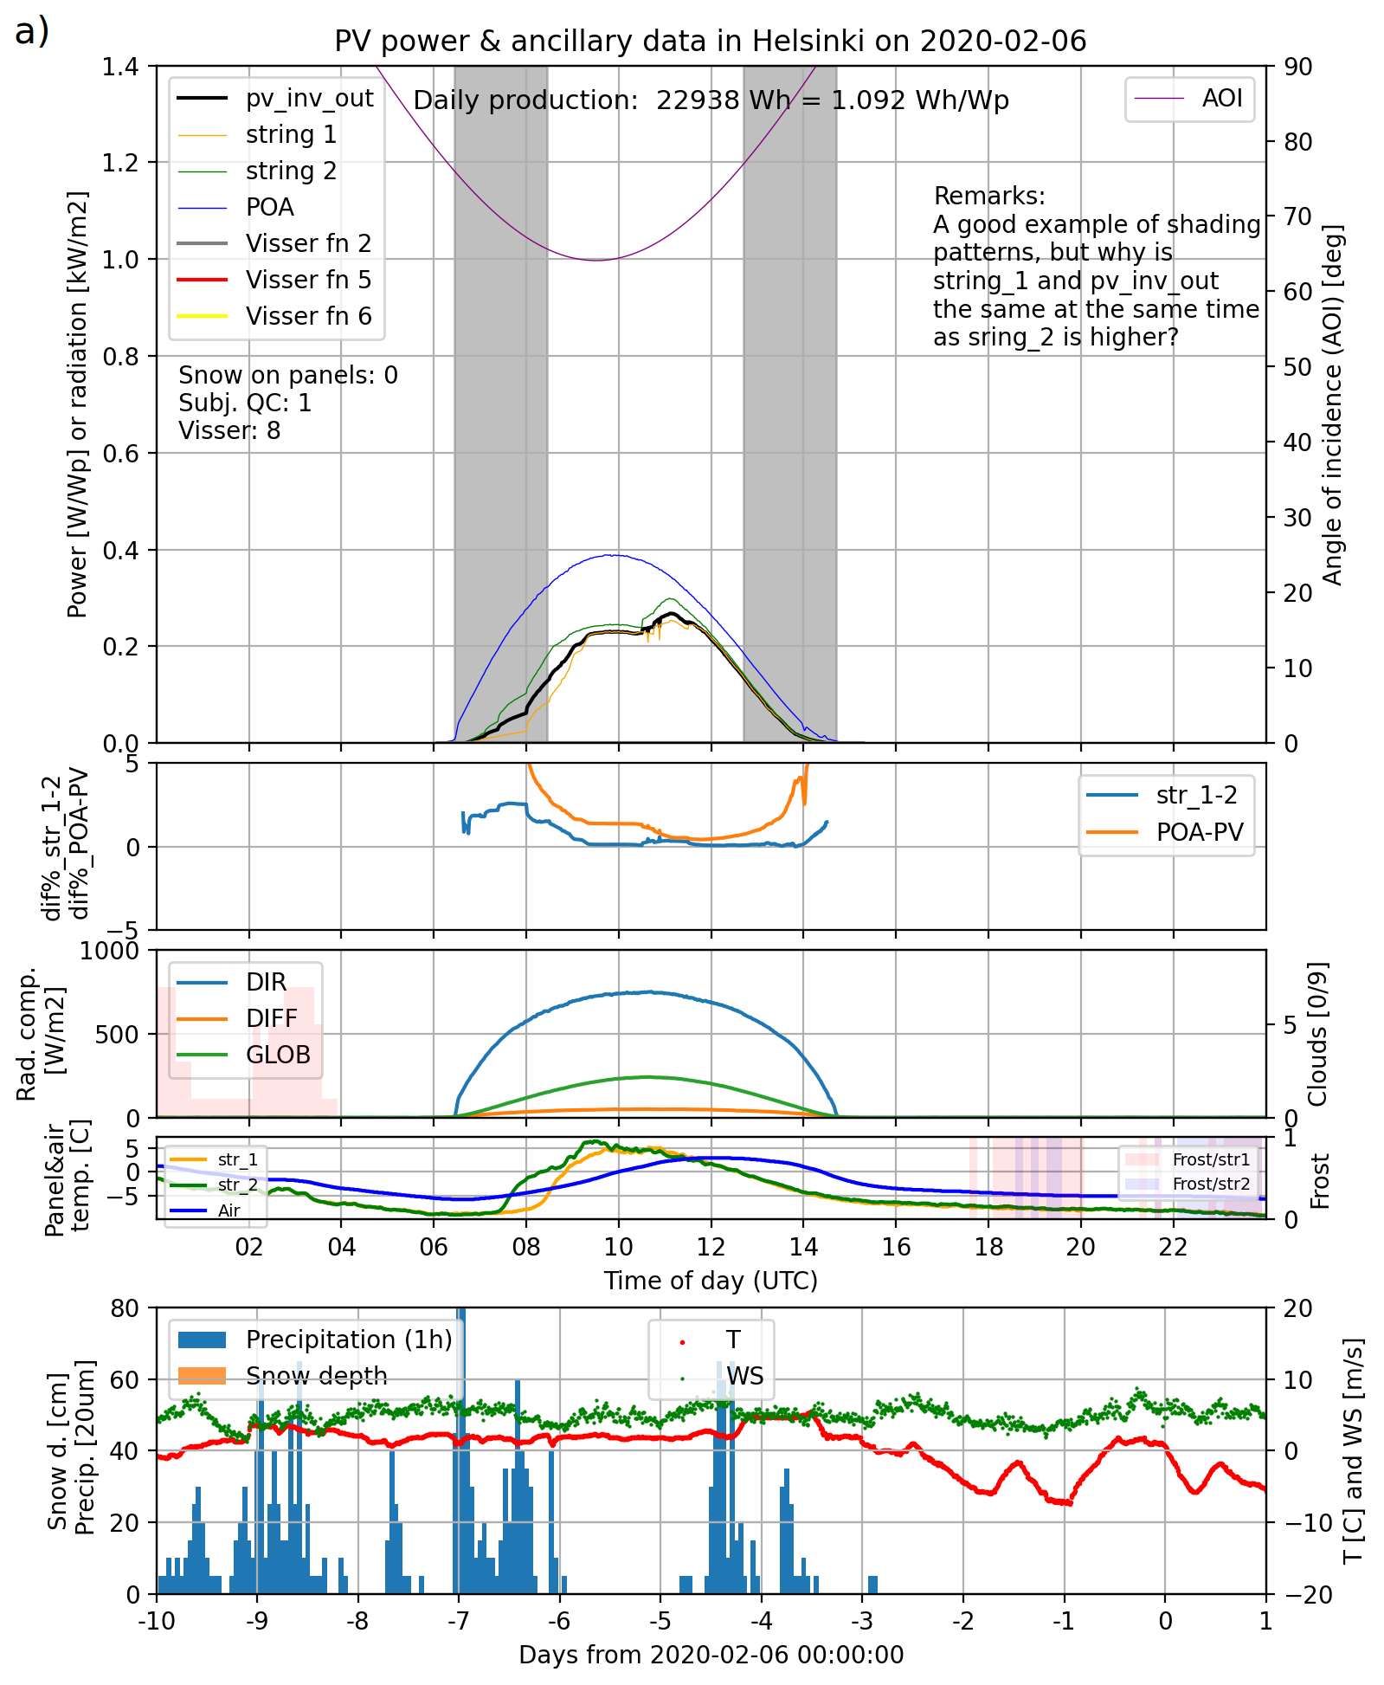

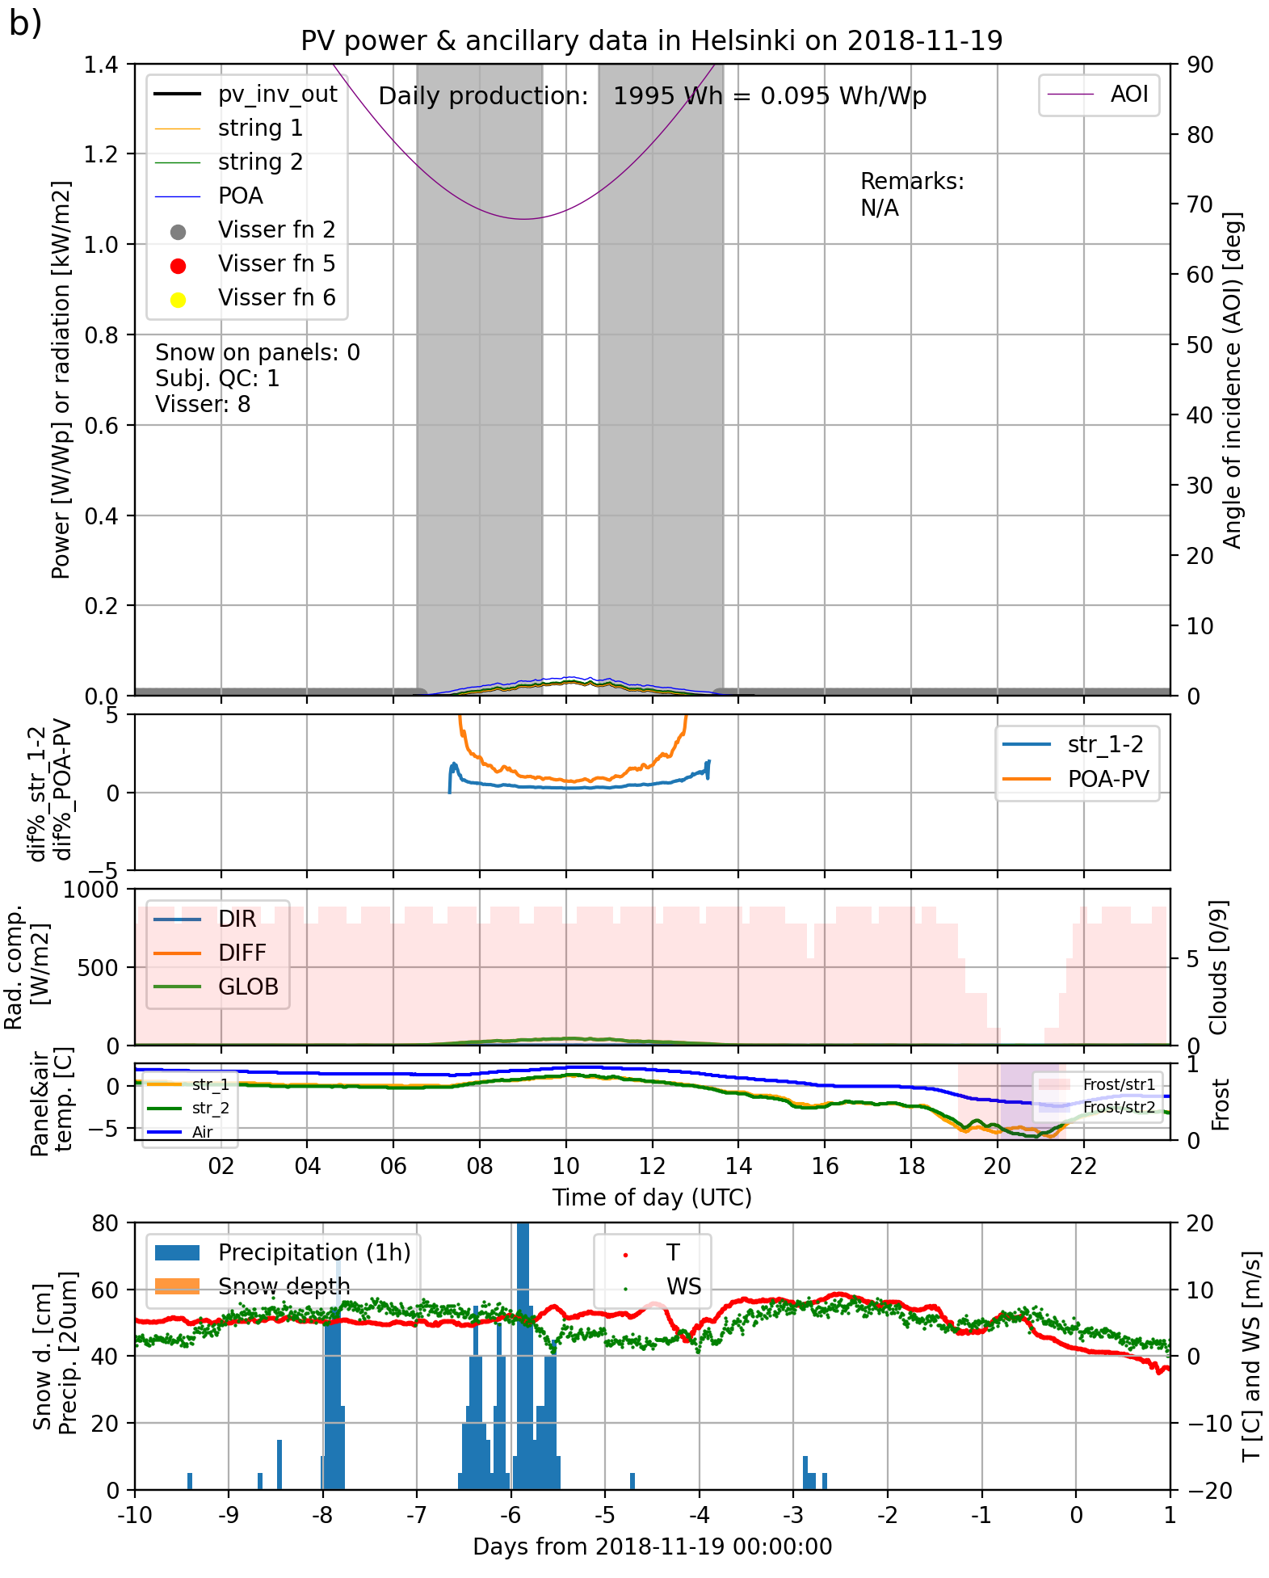

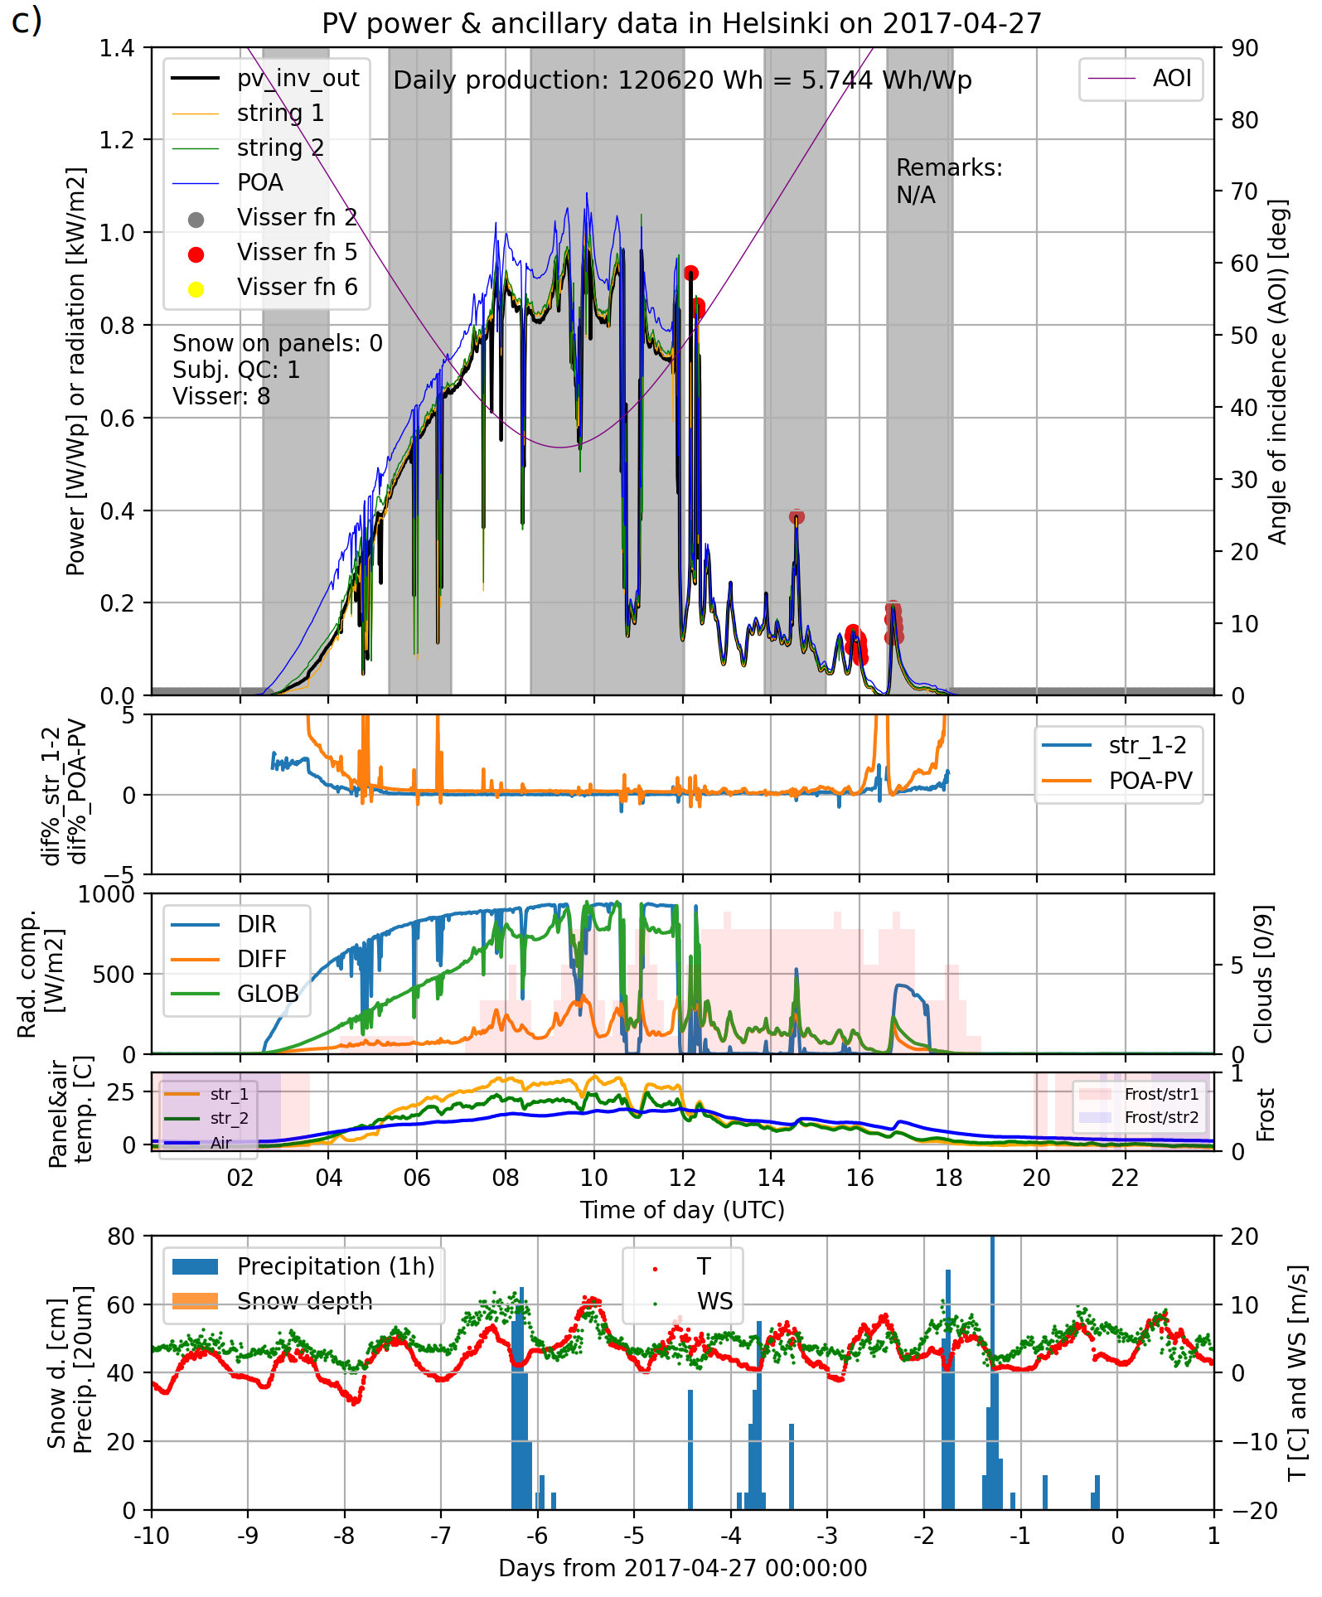
Figure SOX2. An example of cases when the persistence filter (filter 8) was erroneously triggered for low variability during a) clear sky and b) overcast conditions and for high variability c) of P^{meas} in Helsinki. The low/high variability leading to low/high variance can be seen in “pv_inv_out”, string_1” and “string_2” in the topmost graphs. See the explanation for the graph details in the Figure 3 of the article proper.

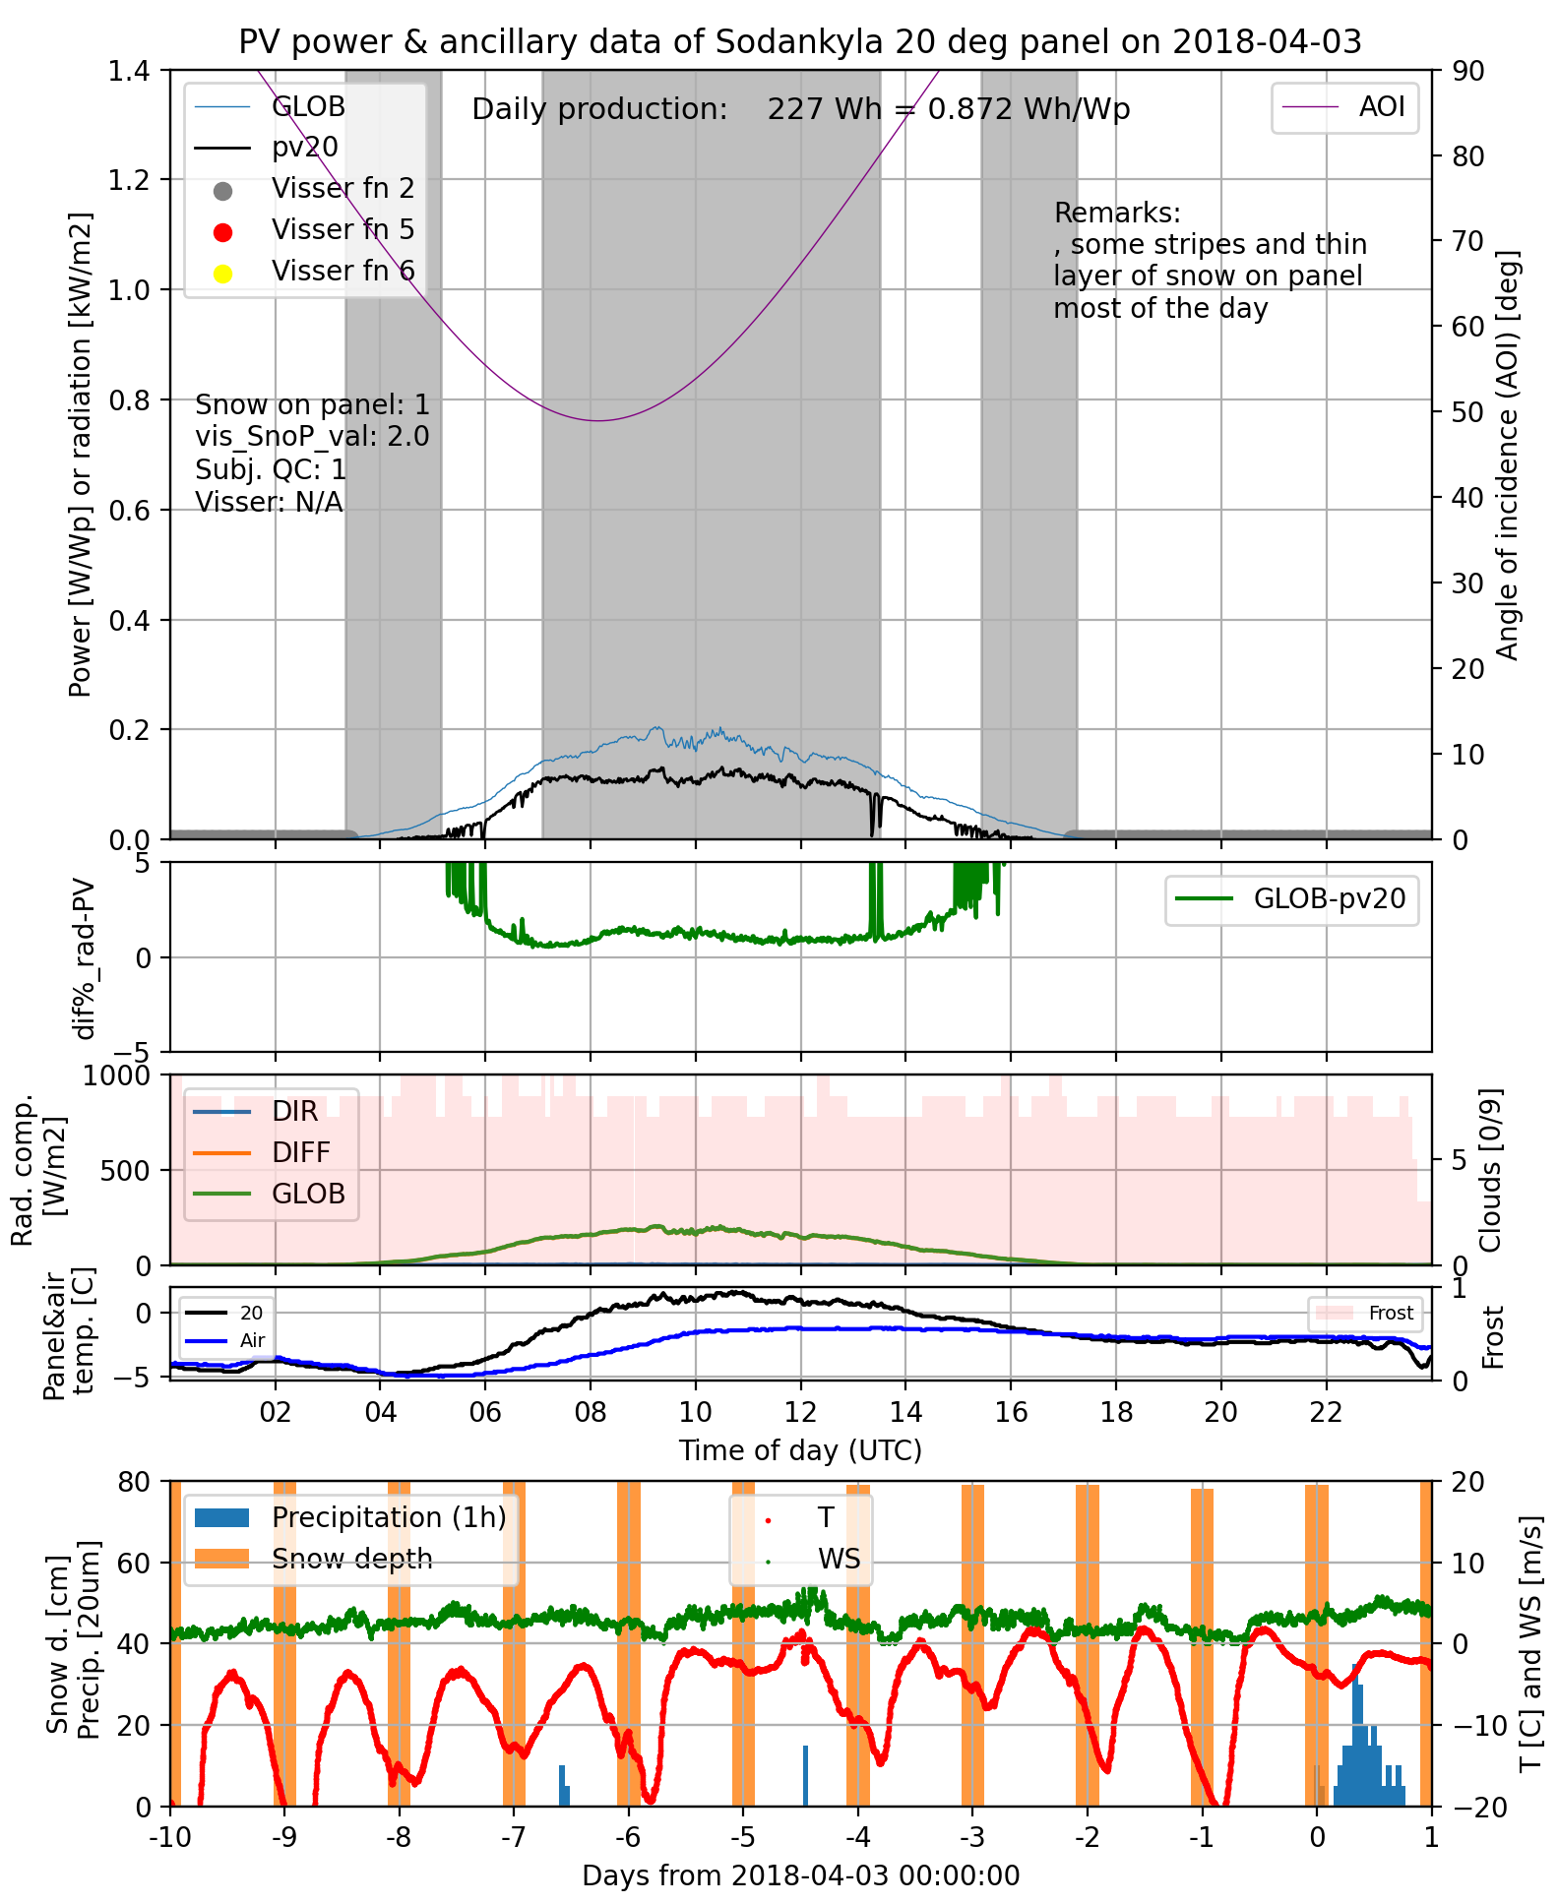
Figure S03. An example of low irradiation day from Sodankylä on 2018-04-03, when P^{meas} shows high variability somewhat similar to the Kuopio “wake-up” problem.
Filter 9: daily energy ratio filter
The last filter is the daily energy ratio filter. The single filtered case in Helsinki (6 March 2019, Figure S04) is most probably due to different snow cover of the two module strings. There are no filtered cases in Kuopio. In Sodankylä, different snow cover of the 20° and 90° modules was the primary cause of filtering (46/56). 10/56 cases were due to partially missing PV data from the 90° module probably due to the 90° module microinverter error.
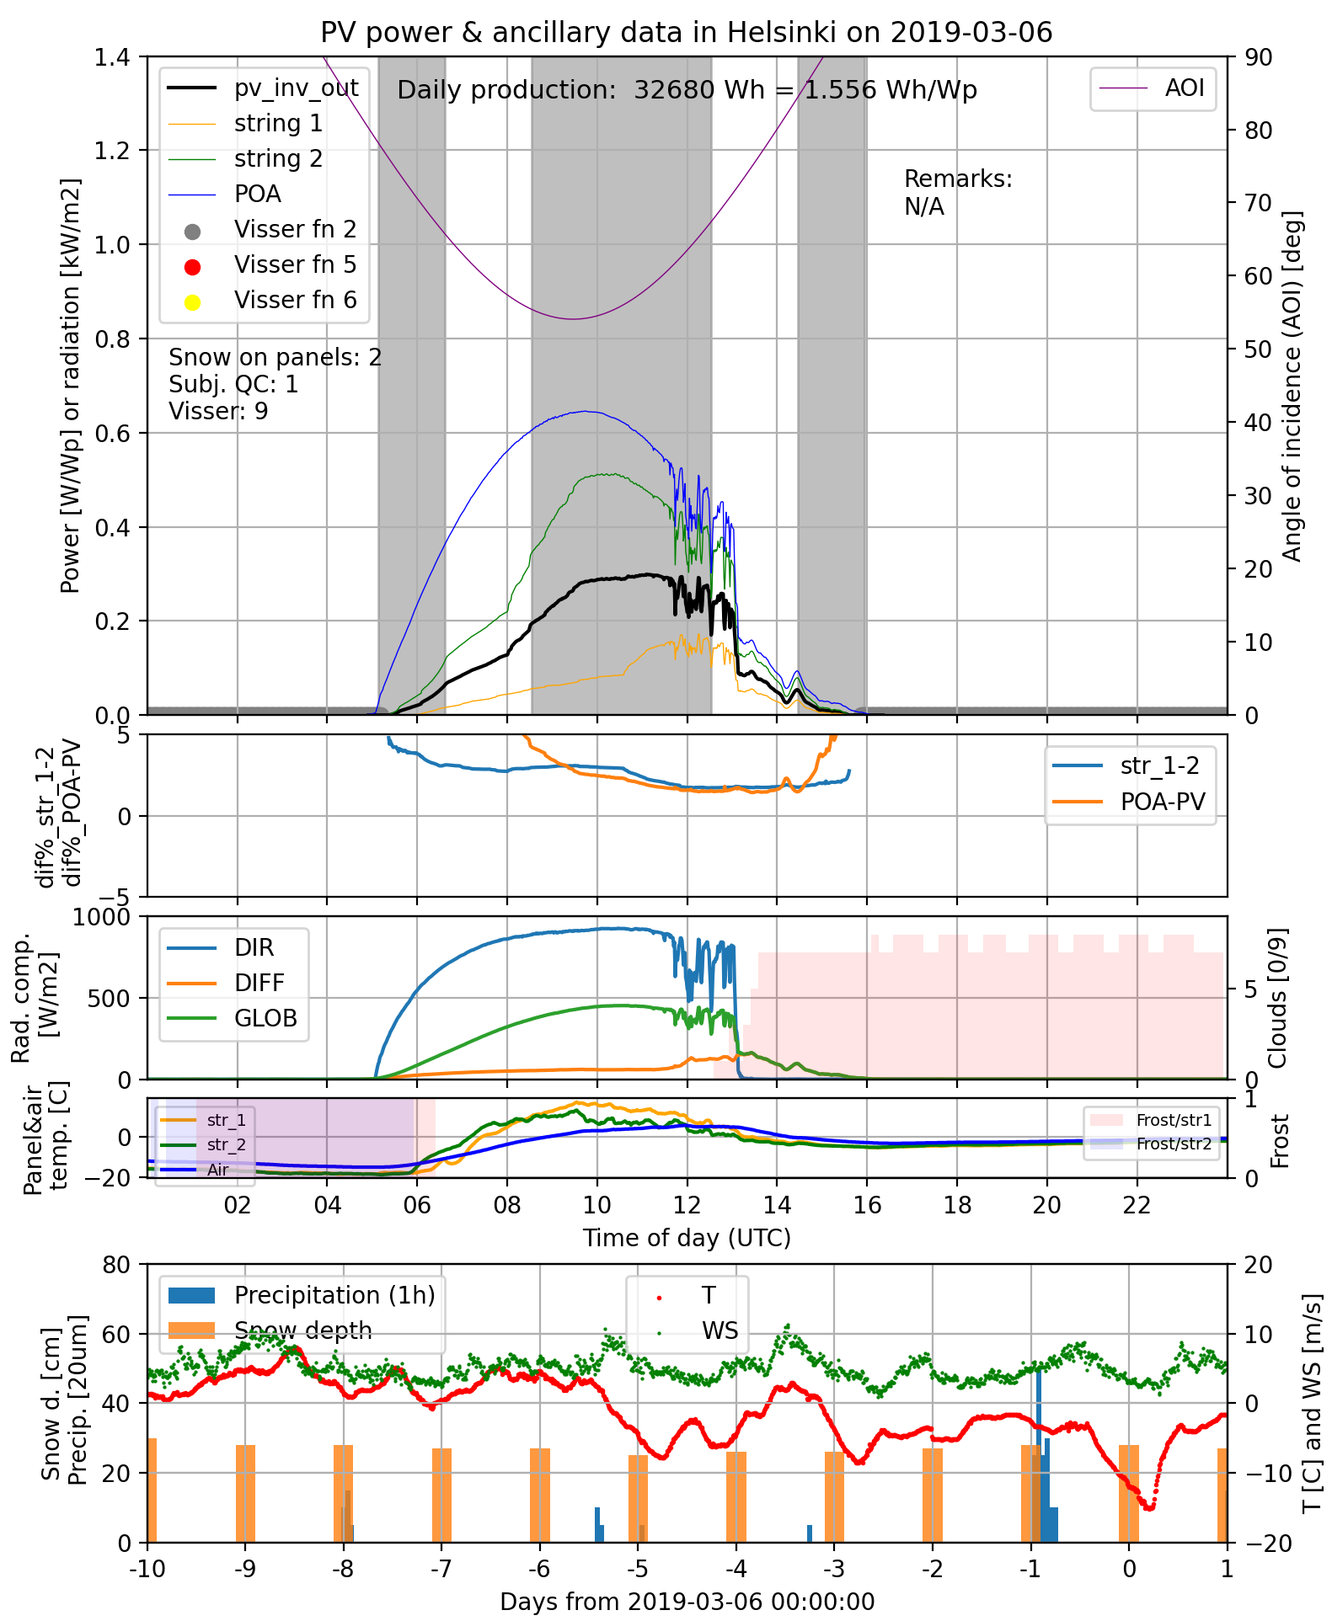
Fig SO4. The single case from Helsinki, when the daily energy ratio filter (filter number 9) triggered. The probable cause of triggering is not a fault on the system but different snow cover on the modules evident from the different power levels of strings 1 and 2 along and snow depth data.
The DER filter in its applied form did not detect the faulty inverter in Kuopio, even though the fault was such that in principle it could have been detected. The fault appeared as a sudden, sustained, drop of ca. 50% in string 2 production in Kuopio starting on 22 October 2021. The drop did not recover within the period investigated in this study (until 31 December 2021). The reason for the drop was later found out to be burned fuses in the inverter. Burning of the fuses was probably due to oxidized connections of the security switch of the string 2. The fix in August 2023 included new fuses, new security switch and protective casing of the security switch.

One of the problems of the DER filter is the constant, instead of varying, maximum allowed deviation; here, as in Visser et al. 2022, it is 0.25. More optimally, the maximum allowed deviation should vary depending on cloudiness i.e. available radiation.

S4: Description of shade casting obstacles in the PV sites
The information provided here supports the text of the Chapter 2.3.3 Shading as it gives a detailed description of obstacles casting shades on the PV modules.
Helsinki PV system
As described in an earlier study (Böök et al. 2020), when viewing from the 𝐺_{𝑃𝑂𝐴}
measurement location in the middle of the module field, the most notable obstacles surrounding the module field are the tilted roof of the building’s inner yard to north and northeast, handrails of a walk way and a radar radom to northeast, a two-degree wide and nine-degree high lattice mast and a church tower to south, an air conditioning duct to southwest and west, the same tilted roof to the west and north, solar radiation measurement platform to northwest and an air conditioning engine room to north.
In addition to these obstacles surrounding the modules there is a wooden walkway and a cable rack between the two strings of the PV system that causes significant shadowing on modules of string 1 (Figure 2). There is an opening between the two module strings, string 2 being nearer to the edge of the roof. The distance between the last module row of the string 2 and the first module row of the string 1 is 330 cm. The walkway and a cable rack are situated in this opening and partially shade the module rows of the string 1 during low sun elevation angles and from ca. 45° to ca. 225° sun azimuth angles as can be seen in the lower part of Figure 2a of the article proper. The cable rack in its present form is 125 cm away from the first module row of string 2 and mostly ca. 50 cm high with the last 5 m at the southwest end ca. 80 cm high measured from the roof. During the first weeks after the commissioning of the PV system, on top of the cable rack there was a higher combined handrail and cable rack (Figure S05) that resulted in a stronger partial shading to the string 1 up to ca. 34° sun elevation angle clearly seen in the PV data (Figure S06). This handrail was removed between 22 and 26 September 2015. The handrail removal seems to be the only major change affecting the shading patterns of the PV modules in Helsinki between the commissioning and end of the period of this study, 31 December 2021. The walkway is 25 cm from the first module row of string 2 and has a slightly wavy form being 2 –12 cm higher than the leading edge of the nearest module row. The cable rack and the wooden walkway cause the two strings to have distinct and different shading patterns for the whole period under study, string 1 being affected.
A notable feature is the fact that while the rest of the system has a 160 cm distance between the rows within the two strings, the first and second module rows of the string 1 have smaller distance of 150 cm increasing self-shading and masking effects of the string 1 in comparison to string 2. The concrete slabs used as weights preventing the modules being blown away with strong winds protrude partially above the top edges of the modules at the ends of the module rows increasing self-shading further (Figure 2).
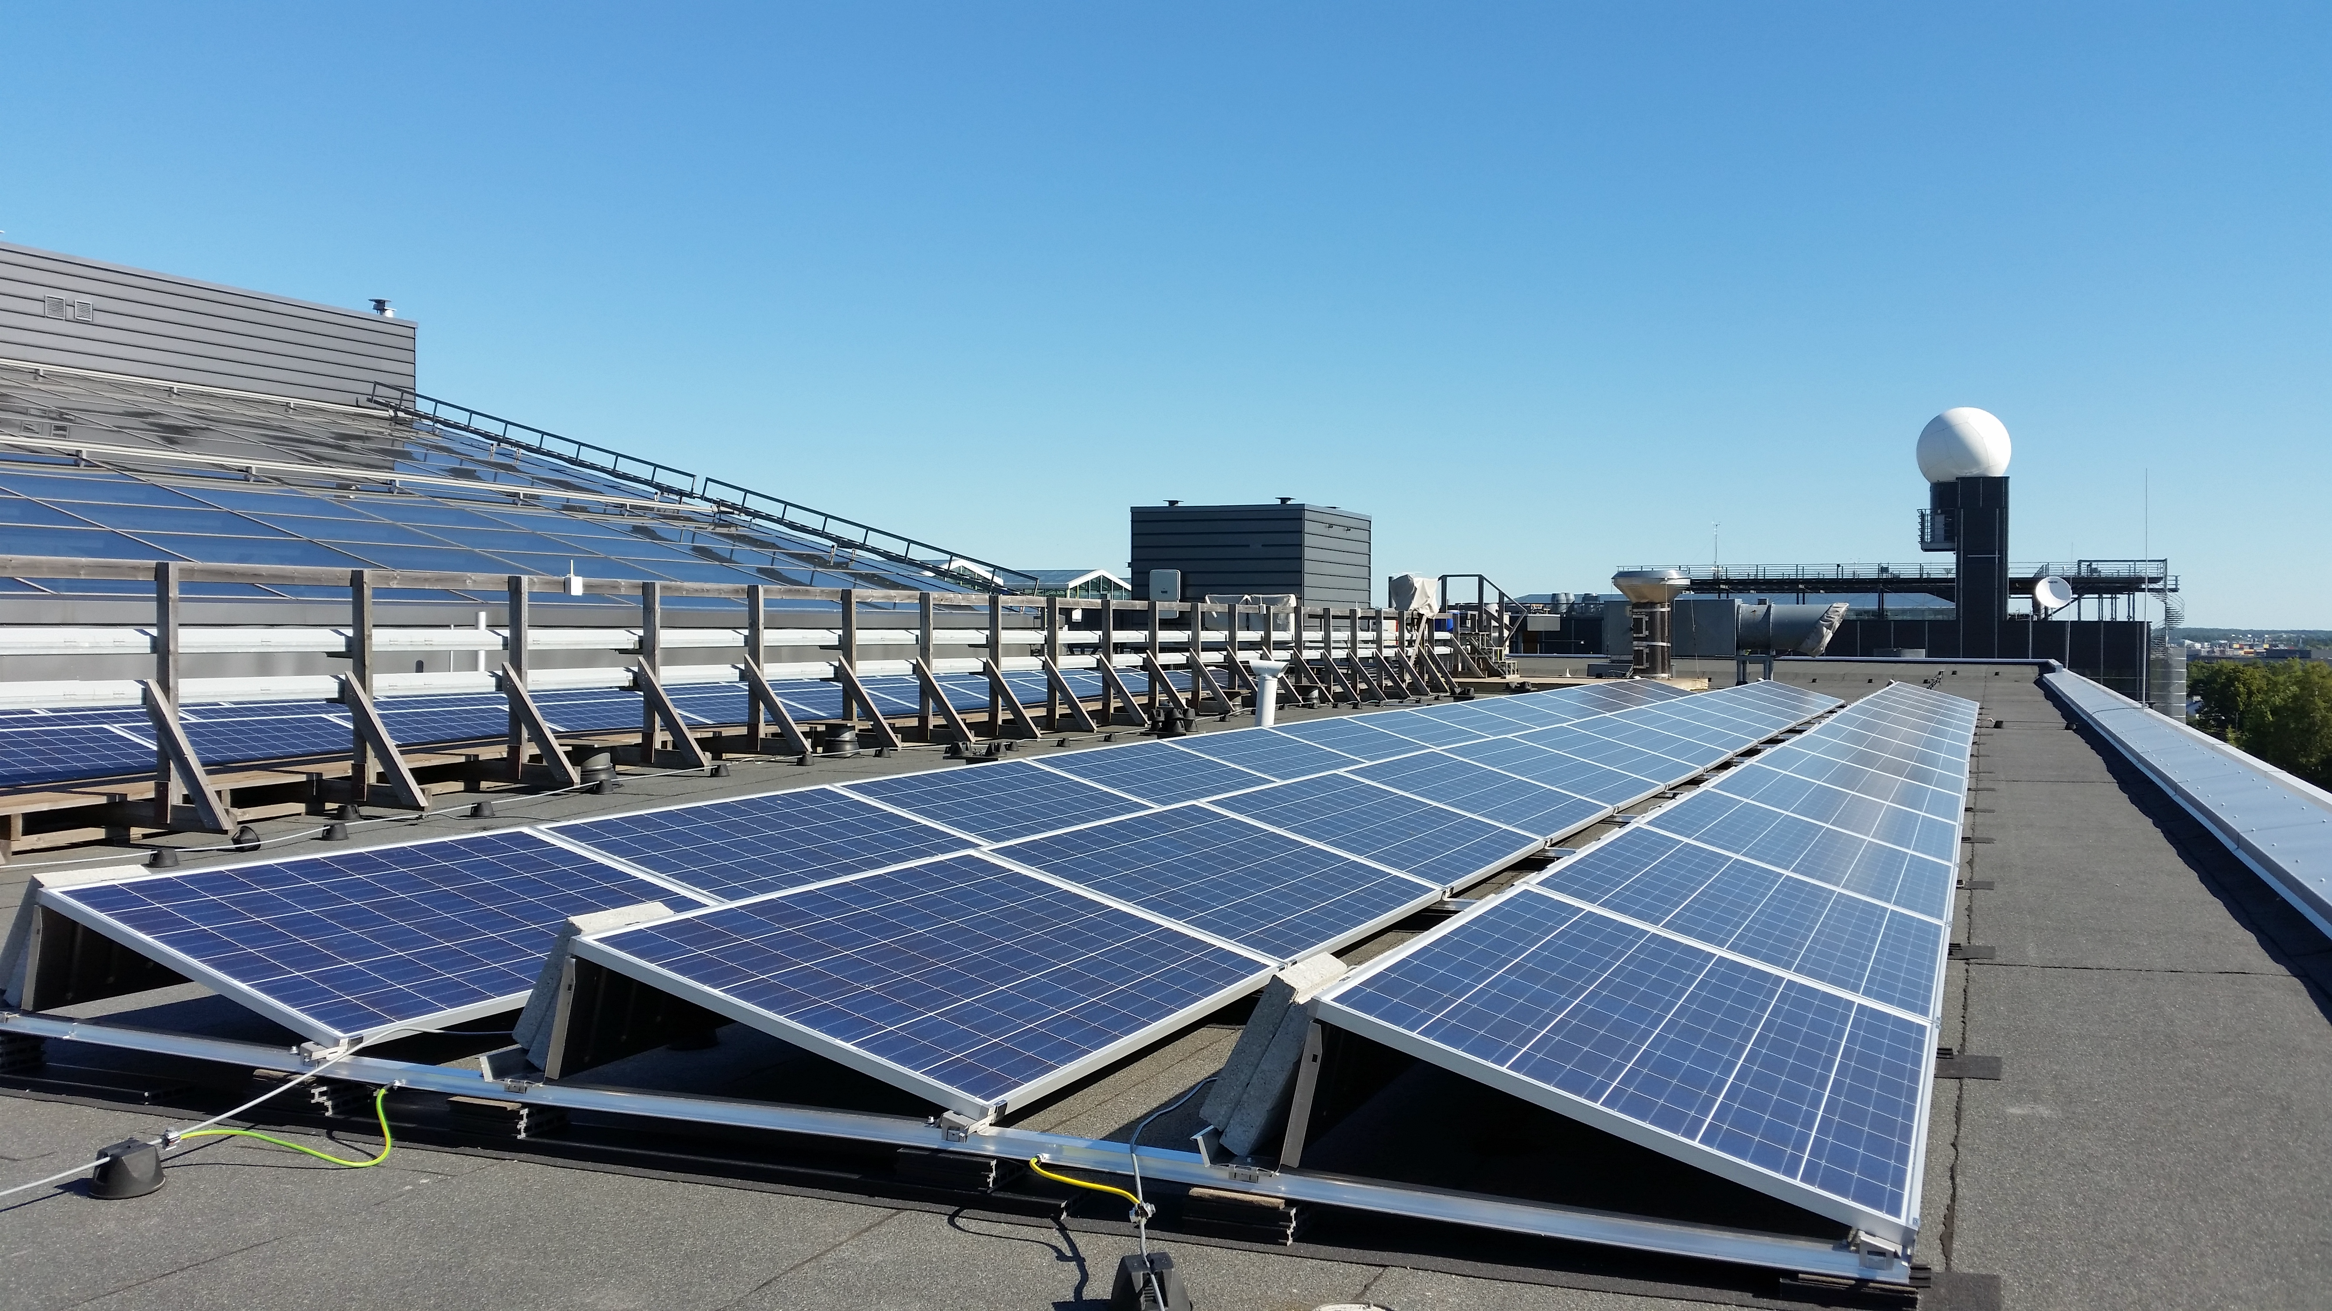
Fig S05. The Helsinki PV site handrail and cable rack on the left side of the image in its higher form between the module strings. When compared to the Figure 2a in the article proper the difference in the handrail/cable rack is clearly visible. The image was taken on 18 August 2015 at 10:51 local time.
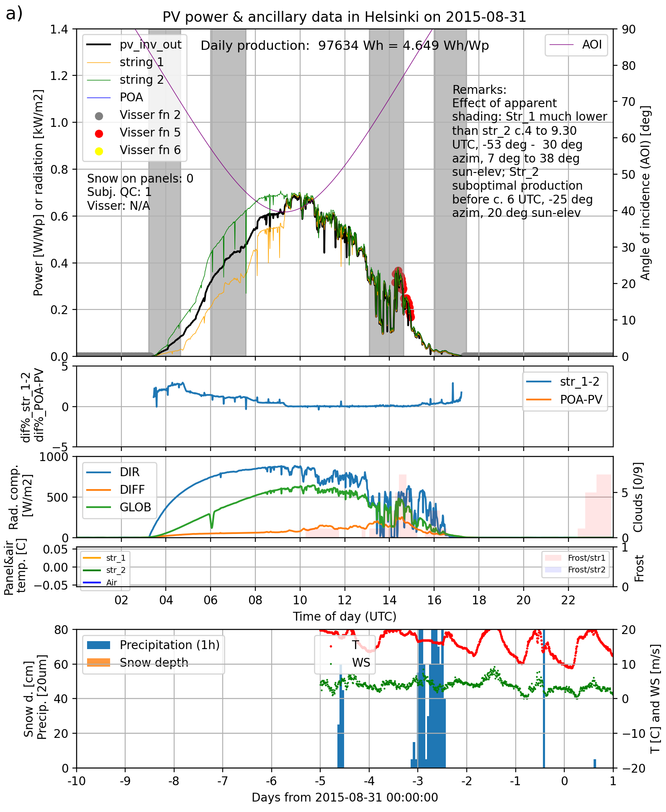

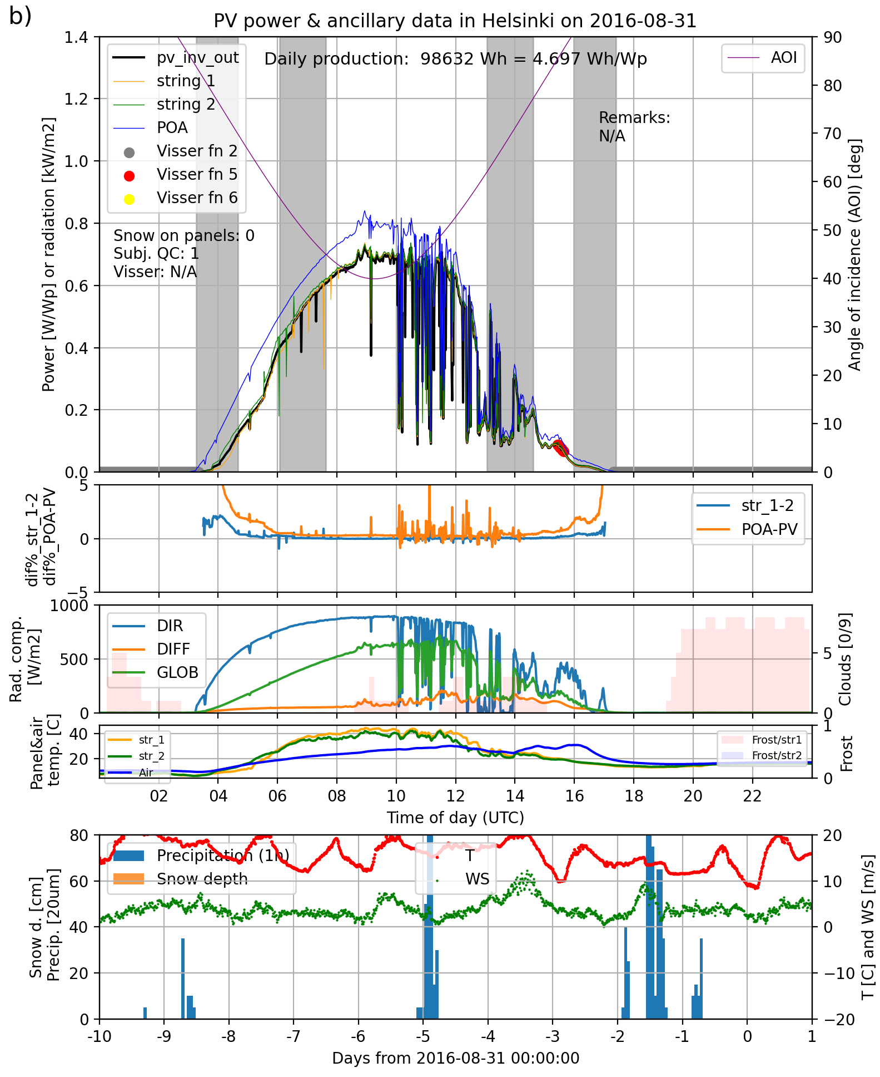
Figure S06. PV data a) before and b) after the removal of the handrail in Helsinki between 22 and 26 September 2015. The handrail casted shadows on “string_1” only. In a) the Pmeas of “string_1” is thus considerably lower than “string_2” during first, clear-sky part of the day. In b) the difference is considerably smaller even though the meteorological conditions are roughly the same.
Kuopio PV system
The view from the module field towards north and north-east is unobstructed and the horizon height is ca. 2°-5°. Between ca. 90° and 170° azimuth angles the modules are partially affected by a shadow cast by a higher section of the university building complex. As this higher section is relatively close to the modules (15 to 50 m depending on the module) it gives differential shadow to the modules and the two strings depending on sun elevation and azimuth. Between 170° and 230° azimuth the horizon height remains mainly below 10° without any major obstacles rising above that. From ca. 230° to 360° again a higher extension (ca. 3 m) of the building close to the modules (2 – 37 m) casts partial and differential shadow on the modules depending on sun elevation and azimuth. A radiation measurement platform, rungs and ventilation equipment on the roof further increase partial shadow in a diffuse manner from the same direction. There has been at least one roof renovation in autumn 2019 when white renovation tents have heightened the southern horizon temporarily during the period under study.
In addition to the surrounding buildings and the horizon further away, there are a few fixed obstacles near or just beside the modules that cast partial shadow on the modules depending on the sun elevation and azimuth. Adjacent to the northwest end of the module rows 2 and 3 of string 2 there is a power distribution pole and a JL-150 Hunter particle collector. The power distribution pole is ca. 1.5 m high and 18 cm wide. The particle collector is 4x43 cm wide and rises ca. 1.5 m above the roof surface. On the opposite side of, and ca. 0.5 m from the same module rows, there are two enclosures related to building services systems. They are ca. 50 cm high and roughly 70 cm wide.
An ambient air temperature sensor with its radiation shield is situated ca. 80 cm south from the front module row of the string 1 in front of the 5th module counted from the north-westernmost edge of the module system. The shield is ca. 15 cm wide and rises ca. 40 cm above the roof surface.
A HALO Photonic lidar has been on the roof during 9 – 30 Oct 2017, 26 June 2019 – 18 Feb 2020 and 27 July 2020 – 8 April 2021 roughly at the same position about one meter south from the front module row of the string 1 in front of the 4th and 5th module beside the temperature sensor radiation shield described above. The top of the lidar instrument rises ca. 80-100 cm above the surface of the roof depending on whether it has been on a pallet or not.
There is an Envinet measurement pole situating ca. 3 m north-west from the north-west edge of the module string 2 and ca. 4 m south of the front module row of string 1. The width of the pole and the measurement sensor is ca. 10 cm with total height ca. 2.5 m.
Installation of the modules is in principle similar to the Helsinki modules. Nevertheless, levelling of the modules has not been as successful as in Helsinki. The modules more closely follow the roof's water drainage slopes in Kuopio, resulting in slightly undulating module rows and about a 2° variation in the module inclination angles. The distance between module rows in Kuopio is larger, 170 cm, compared to 160 cm in Helsinki, causing slightly less self-shading and masking. Also, the concrete slabs used as weights protrude less in Kuopio and are thus less likely to obstruct the rays falling on the modules behind them.

Sodankylä PV system
Nothing to add to the description given in the article Chapter 2.3.3.

S5: Snow clearance incidences of the Sodankylä 20° module
